A Project Report on

# Healthy Naari

Submitted in partial fulfilment of the requirements for the award of the degree of

B.Sc. (Hons.) Computer Application By:

|  |  |
| --- | --- |
| **Examination Roll Number** | **Name of Student** |
| 20VBCA044476 | Priti Kumari |
| 20VBCA044477 | Misha Agrawal |
| 20VBCA044491 | Harish Chandra Mahto |
| 20VBCA044493 | Anjali Kumari |



Department of Computer Science St. Xavier’s College, Ranchi

**2023**

# INDEX

|  |  |  |
| --- | --- | --- |
| **Sl. No** | **Chapter** | **Page** |
| 1 | Synopsis | 3 |
| 2 | Acknowledgement | 6 |
| 3 | Declaration by Candidate | 10 |
| 4 | Certificate of Originality | 14 |
| 5 | Introduction | 18 |
| 6 | User Classes | 20 |
| 7 | Technology Used | 21 |
| 8 | Schematic Representation | 27 |
| 9 | Working Logic | 28 |
| 10 | Classes and Attributes | 35 |
| 11 | Diagrams | 37 |
| 12 | Screenshots and Source | 39 |
| 13 | Future scope | 111 |
| 14 | Conclusion | 112 |

**SYNOPSIS**

## Title of the Project

Healthy Naari

## Objective of the Project

The goal of this project is to educate girls and women about their menstrual cycle, including what happens during menstruation, how to manage menstrual bleeding, and how to track their menstrual cycle.

A project may aim to increase access to menstrual products such as pads, tampons, and menstrual cups.

## Project Category

* Website

## HTML, CSS, Bootstrap, PHP

The entirety of this project is divided into two sub sections mainly Frontend and Backend. Frontend is part of any website which is visible to the end users (those who are going to visit our website), which is further divided into Bootstrap, HTML and CSS.

Bootstrap is a free, open source front-end development framework for the creation of websites and web apps. Designed to enable responsive development of mobile-first websites, Bootstrap provides a collection of syntax for template designs.

HTML specifically stands for Hypertext Markup Language which is considered mere backbone, that is, provides a working structure to any website.

Then, CSS stands for Cascading Style Sheet which is often referred to as styling component of any website which provides a great look and feel to a website. With various attributes and properties, the entire discussion is beyond the scope of this project.

PHP, amongst various other backend languages, has been used in our project. It is used to provide the functional logic of our website.

**Software requirements**

## Front End

* + Bootstrap
  + Hypertext Markup Language (HTML)
  + Cascading Style Sheet (CSS)

## Back End

* + PHP: Hypertext Pre-processor (PHP)

## Database

* + MySQL Database (MariaDB)

## Hosting and Domain

* + Localhost
  + Github

## Web Browser

* + Any web browser capable of sending and receiving HTTPS requests. (Ex. Google Chrome, Internet Explorer)

**Hardware requirements**

* A stable internet connection (for loading assets such as images)
* At least 100MB storage
* At least 1GB RAM
* A functional output device (Monitors)
* A functional input device (Mouse and Keyboard)

# ACKNOWLEDGEMENT

I, Priti Kumari, would like to express my sincere gratitude to Mr. Ritesh Kumar for his support, valuable time, and guidance. This report would not have been possible without his motivation and contribution.

Also, I would like to thank Mr. Gurpreet Singh and Mr. Suryanarayan Prasad for providing great facilities and environment, and also for giving us such a wonderful opportunity to enhance our skills and knowledge.

Finally, I would also like to thank my parents and friends who helped me a lot in finalizing this project within the limited time frame.

Priti Kumari

20VBCA044476

# ACKNOWLEDGEMENT

I, Misha Agrawal, would like to express my sincere gratitude to Mr. Ritesh Kumar for his support, valuable time, and guidance. This report would not have been possible without his motivation and contribution.

Also, I would like to thank Mr. Gurpreet Singh and Mr. Suryanarayan Prasad for providing great facilities and environment, and also for giving us such a wonderful opportunity to enhance our skills and knowledge.

Finally, I would also like to thank my parents and friends who helped me a lot in finalizing this project within the limited time frame.

Misha Agrawal

20VBCA044477

# ACKNOWLEDGEMENT

I, Harish Chandra Mahto, would like to express my sincere gratitude to Mr. Ritesh Kumar for his support, valuable time, and guidance. This report would not have been possible without his motivation and contribution.

Also, I would like to thank Mr. Gurpreet Singh and Mr. Suryanarayan Prasad for providing great facilities and environment, and also for giving us such a wonderful opportunity to enhance our skills and knowledge.

Finally, I would also like to thank my parents and friends who helped me a lot in finalizing this project within the limited time frame.

Harish Chandra Mahto 20VBCA044491

# ACKNOWLEDGEMENT

I, Anjali kumari, would like to express my sincere gratitude to Mr. Ritesh Kumar for his support, valuable time, and guidance. This report would not have been possible without his motivation and contribution.

Also, I would like to thank Mr. Gurpreet Singh and Mr. Suryanarayan Prasad for providing great facilities and environment, and also for giving us such a wonderful opportunity to enhance our skills and knowledge.

Finally, I would also like to thank my parents and friends who helped me a lot in finalizing this project within the limited time frame.

Anjali Kumari

20VBCA044493

# DECLARATION BY CANDIDATE

I the undersigned declare that the project report entitled “Healthy Naari” is based on my work carried out during my group Project under the supervision of Mr. Ritesh Kumar.

This project work has been submitted for partial fulfilment of the requirement of the degree of B.Sc. (Hons.) Computer Application for the session 2020 – 2023. The work done in the report is original and has been done by me under the general supervision of my supervisor.

Priti Kumari

20VBCA044476

# DECLARATION BY CANDIDATE

I the undersigned declare that the project report entitled “Healthy Naari” is based on my work carried out during my Group Project under the supervision of Mr. Ritesh Kumar.

This project work has been submitted for partial fulfilment of the requirement of the degree of B.Sc. (Hons.) Computer Application for the session 2020 – 2023. The work done in the report is original and has been done by me under the general supervision of my supervisor.

Misha Agrawal

20VBCA044477

# DECLARATION BY CANDIDATE

I the undersigned declare that the project report entitled “Healthy Naari” is based on my work carried out during my Group Project under the supervision of Mr. Ritesh Kumar.

This project work has been submitted for partial fulfilment of the requirement of the degree of B.Sc. (Hons.) Computer Application for the session 2020 – 2023. The work done in the report is original and has been done by me under the general supervision of my supervisor.

Harish Chandra Mahto 20VBCA044491

# DECLARATION BY CANDIDATE

I the undersigned declare that the project report entitled “Healthy Naari” is based on my work carried out during my Group Project under the supervision of Mr. Ritesh Kumar.

This project work has been submitted for partial fulfilment of the requirement of the degree of B.Sc. (Hons.) Computer Application for the session 2020 – 2023. The work done in the report is original and has been done by me under the general supervision of my supervisor.

Anjali Kumari

20VBCA044493

# CERTIFICATE OF ORIGINALITY

The Project Report entitled “Healthy Naari”, is hereby approved as a creditable work and has been presented nicely to meet its acceptance as a prerequisite to the degree for which it has been submitted.

It is understood that by this approval, the undersigned does not necessarily endorse any conclusion drawn or opinion expressed therein, but approves the Project Report for the purpose for which it is submitted.

|  |  |
| --- | --- |
| Priti Kumari | Mr.Ritesh Kumar  Department of Computer Science St. Xavier’s College, Ranchi |

|  |  |
| --- | --- |
| (Internal Examiner) | (External Examiner) |

(Dr. Swarat Chaudhari) Head of the Department

Department of Computer Science St. Xavier’s College, Ranchi

# CERTIFICATE OF ORIGINALITY

The Project Report entitled “Healthy Naari”, is hereby approved as a creditable work and has been presented nicely to meet its acceptance as a prerequisite to the degree for which it has been submitted.

It is understood that by this approval, the undersigned does not necessarily endorse any conclusion drawn or opinion expressed therein, but approves the Project Report for the purpose for which it is submitted.

|  |  |
| --- | --- |
| Misha Agrawal | Mr. Ritesh Kumar  Department of Computer Science St. Xavier’s College, Ranchi |

|  |  |
| --- | --- |
| (Internal Examiner) | (External Examiner) |

(Dr. Swarat Chaudhari) Head of the Department

Department of Computer Science St. Xavier’s College, Ranchi

# CERTIFICATE OF ORIGINALITY

The Project Report entitled “Anjali Kumari”, is hereby approved as a creditable work and has been presented nicely to meet its acceptance as a prerequisite to the degree for which it has been submitted.

It is understood that by this approval, the undersigned does not necessarily endorse any conclusion drawn or opinion expressed therein, but approves the Project Report for the purpose for which it is submitted.

|  |  |
| --- | --- |
| Harish Chandra Mahto | Mr. Ritesh Kumar  Department of Computer Science St. Xavier’s College, Ranchi |

|  |  |
| --- | --- |
| (Internal Examiner) | (External Examiner) |

(Dr. Swarat Chaudhari) Head of the Department

Department of Computer Science St. Xavier’s College, Ranchi

# CERTIFICATE OF ORIGINALITY

The Project Report entitled “Healthy Naari”, is hereby approved as a creditable work and has been presented nicely to meet its acceptance as a prerequisite to the degree for which it has been submitted.

It is understood that by this approval, the undersigned does not necessarily endorse any conclusion drawn or opinion expressed therein, but approves the Project Report for the purpose for which it is submitted.

Anjali Kumari

|  |  |
| --- | --- |
|  | Mr. Ritesh Kumar  Department of Computer Science St. Xavier’s College, Ranchi |

|  |  |
| --- | --- |
| (Internal Examiner) | (External Examiner) |

(Dr. Swarat Chaudhari) Head of the Department

Department of Computer Science St. Xavier’s College, Ranchi

# INTRODUCTION

The project entitled “Healthy Naari”, made by our team is a fully functional project based on web development. Due to the simplistic design of our project, it renders to be very user friendly and can be used by anyone belonging to any age group what so ever.

The main aim of this project is to educate girls and women about their menstrual cycle, including what happens during menstruation, how to manage menstrual bleeding, and how to track their menstrual cycle.

A project may aim to increase access to menstrual products such as pads, tampons, and menstrual cups.

Some of the salient features of our web application are as follows:

* **Ease of use –** Simple yet elegant looking interface which is appealing to the end user irrespective of intelligence Quotient (IQ), age, acquaintance with technology what so ever.
* **Completely open source and free to use –** With the Healthy Naari which is based Women Menstrutation, our goal has (and will) never be to earn profit out of even if needs be. Also, it is open source meaning anyone having expertise in web development can tinker into the internal workings of our project and contribute to its improvement if interested.
* **Introduction about Menstrutation -**
* Menstruation is a natural process that occurs in the female reproductive system.
* It involves the shedding of the lining of the uterus, which occurs approximately once a month in women who have reached puberty and are not pregnant or breastfeeding.
* Menstruation is regulated by hormones, specifically estrogen and progesterone.
* The menstrual cycle typically lasts 28-32 days, but can vary for each woman.
* Menstrual bleeding can last anywhere from 3-7 days, and is characterized by vaginal bleeding.
* Menstrual bleeding can last anywhere from 3-7 days, and is characterized by vaginal bleeding.
* Hormonal changes during the menstrual cycle can also cause emotional symptoms such as mood swings, irritability, and anxiety.
* Menstruation is an important aspect of reproductive health, and it is important for women to understand how their bodies work and how to manage their menstrual cycles effectively.
* Options for menstrual management include menstrual products such as pads and tampons, menstrual cups, and period underwear.

          

# USER CLASSES

Due to the fairly limited scope of this project, it has the following user classes –

**End Users–** (or more specifically the general public). This class focuses more those who are actually going to use the web application. They are restricted (but not limited) to casting their votes, viewing polling results when the results are declared and they can also download their voting certificates if required.

**Database Administrators -** This class pertains to those people who work on the logical and structural aspects of this project. A database administrator is one who is responsible for defining the structure of any database, the tables employed in it (also called relations), datatypes of each of its columns, integrity constraints such as primary keys, default values etc. This project uses one database and a single table to store tabular data.

**Software Developers –** The next and last user class of this project focuses more on the maintenance aspect of the system. These users (programmers) will be responsible for making necessary (or demanded) changes in the web application if needs be in the future.

The entire set of tools required to modify/ rectify the website can be accessed by these users including source code, available political parties, the required libraries employed in making this project. Here, source code refers to all the lines written (and understood) by contributors of this project and, finding bugs, scope of improvement of this project is the sole responsibility of developers and fellow contributors (if any).

# TECHNOLOGY USED

## Overall Concept

The entirety of this project is based on Web Development, the details of which are as under:

**BOOTSTRAP**

Bootstrap is a free and open-source front-end web development framework that helps developers to create responsive and mobile-first web applications. It is a popular framework that provides a set of pre-built HTML, CSS, and JavaScript components and templates that can be easily customized and used to create modern and responsive web pages.

Bootstrap was developed by Twitter and is now maintained by a community of developers. It is based on HTML, CSS, and JavaScript and supports a wide range of browsers and devices. Some of the key features of Bootstrap include a responsive grid system, pre-built CSS classes for typography and other common elements, and a range of JavaScript plugins that add interactive functionality to web pages.

Bootstrap is widely used by developers to create websites, web applications, and mobile applications. It provides a solid foundation for building responsive and mobile-friendly user interfaces quickly and efficiently.Top of Form

## HTML

HTML, CSS, and JavaScript were used in building the frontend design of the static website. The HyperText Markup Language or HTML is the standard markup language for documents designed to be displayed in a web browser. It can be assisted by technologies such as Cascading Style Sheets (CSS) and scripting languages such as JavaScript.

Web browsers receive HTML documents from a web server or from local storage and render the documents into multimedia web pages. HTML describes the structure of a web page semantically and originally included cues for the appearance of the document.

HTML elements are the building blocks of HTML pages. With HTML constructs, images and other objects such as interactive forms may be embedded into the rendered page. HTML provides a means to create structured documents by denoting structural semantics for text such as headings, paragraphs, lists, links, quotes, and other items. HTML elements are delineated by tags, written using angle brackets. Tags such as <img/> and <input/> directly introduce content into the page. Other tags such as <p> surround and provide information about document text and may include other tags as sub-elements. Browsers do not display the HTML tags but use them to interpret the content of the page.

HTML can embed programs written in a scripting language such as JavaScript, which affects the behaviour and content of web pages. The inclusion of CSS defines the look and layout of content. The World Wide Web Consortium (W3C), the former maintainer of the HTML and current maintainer of the CSS standards, has encouraged the use of CSS over explicit presentational HTML since 1997.

## CSS (Cascading Style Sheet)

Cascading Style Sheets (CSS) is a style sheet language used for describing the presentation of a document written in a markup language such as HTML. CSS is a cornerstone technology of the World Wide Web, alongside HTML and JavaScript.

CSS is designed to enable the separation of presentation and content, including layout, colours, and fonts. This separation can improve content accessibility, provide more flexibility and control in the specification of presentation characteristics, enable multiple web pages to share formatting by specifying the relevant CSS in a separate

.css file which reduces complexity and repetition in the structural content as well as enabling the .css file to be cached to improve the page load speed between the pages that share the file and its formatting.

Separation of formatting and content also makes it feasible to present the same markup page in different styles for different rendering methods, such as on-screen, in print, by voice (via speech-based browser or screen reader), and on Braille-based tactile devices. CSS also has rules for alternate formatting if the content is accessed on a mobile device.

## JavaScript

**(Part of the stack but not used in our project)**

JavaScript often abbreviated as JS, is a programming language that conforms to the ECMAScript specification. JavaScript is high-level, often just-in-time compiled, and multi-paradigm. It has curly-bracket syntax, dynamic typing, prototype-based object orientation, and first- class functions.

Alongside HTML and CSS, JavaScript is one of the core technologies of the World Wide Web. Over 97% of websites use their client-side for web page behaviour, often incorporating third-party libraries. All major web browsers have a dedicated JavaScript engine to execute the code on the user's device.

As a multi-paradigm language, JavaScript supports event-driven, functional, and imperative programming styles. It has application programming interfaces (APIs) for working with text, dates, regular expressions, standard data structures, and the Document Object Model (DOM).

## PHP (Hypertext Pre-processor)

For the backend and logical part of our project, we have used PHP language, the details of which are as follows:

PHP is an open-source server-side scripting language that many developers use for web development. It is also a general-purpose language that you can use to make lots of projects, including Graphical User Interfaces (GUIs). The abbreviation PHP initially stood for Personal Homepage. But now it is a recursive acronym for Hypertext Pre-processor. The first version of PHP was launched 26 years ago. Now it's on version 8, initially released in November 2020.

PHP is mostly used for making web servers. It runs on the browser and is also capable of running in the command line. So, if you don't feel like showing your code output in the browser, you can show it in the terminal.

PHP has many advantages that have made it so popular. Some of them are:

* PHP is platform-independent. You don't have to have a particular OS to use it because it runs on every platform, xwhether it's Mac, Windows, or Linux.
* PHP is open source. The original code is made available to everyone who wants to build upon it. This is one of the reasons why one of its frameworks, Laravel, is so popular.
* You can easily connect PHP to all Databases, relational and non- relational. So, it can connect in no time to MySQL, MongoDB, or any other database.
* PHP has a very supportive online community. The official documentation provides guides on how to use the features and you can easily get your problem fixed while stuck.

## MySQL for Database

MySQL is an open-source relational database management system. As with other relational databases, MySQL stores data in tables made up of rows and columns. Users can define, manipulate, control, and query data using Structured Query Language, more commonly known as [SQL](https://www.digitalocean.com/community/tutorials/what-is-sql).

MySQL is one of the most recognizable technologies in the modern big data ecosystem. Often called the most popular database and currently enjoying widespread, effective use regardless of industry, it’s clear that anyone involved with enterprise data or general IT should at least aim for a basic familiarity of MySQL.

Structured Query Language (SQL) is further subdivided into four different command types which are as follows:

* DQL: The data query language (DQL) is the most familiar and is used to run queries on databases and extract information from stored data. For example, selecting and returning the maximum value in a column.
* DDL: A data definition language (DDL) is used to codify a database’s particular structures and schemas. Creating a table or defining data types is an example.
* DCL: A data control language (DCL) defines access, authorizations, and permissions for users and processes accessing the database, including granting administrator privileges, or restricting users to read-only privileges only.
* DML: And finally, a data manipulation language (DML) is used to make modifications on existing components of a database, like inserting records, updating values in cells, or deleting data.

# SCHEMATIC REPRESENTATION

Landing Page

About

Problems

Myths

Shopping

Registration

# REGISTRATION OR LOGIN PAGE

After the home page of our project is visited, one of the first hyperlinks is the Register page. Upon opening the Registration page, users get to interact with the following options:

* Users are prompted to register in the Registration page which contains the following entities:
  + First Name
  + Last name
  + Gender
  + Email Address
  + Password
  + Mobile Number

* They are supposed to fill all the required details in the registration page.
* When users are already register in the websites then next time they are only supposed to login in the website.
* Users are prompted to register in the Registration page which contains the following entities:
* Email Address
* Password
* During registration, users are required to enter their names, gender, email address, Password, Mobile Number.

# SHOPPING

* Product browsing: The shopping page should allow users to browse the available products related to women's periods, such as menstrual pads, tampons, menstrual cups, period panties, etc. Users should be able to view product details, including images, descriptions, and prices.
* Search: The shopping page should have a search bar that allows users to search for specific products or brands. This can help users find what they are looking for quickly and easily.
* Filter and sorting: The shopping page should allow users to filter products based on various criteria, such as price, brand, size, absorbency level, and more. Additionally, users should be able to sort products based on different parameters, such as price (low to high or high to low), popularity, or ratings.
* Add to cart: The shopping page should allow users to add products to their shopping cart. The cart should display the items that have been added, along with the total cost and any applicable taxes or shipping fees.
* Checkout: The shopping page should have a secure checkout process that allows users to enter their shipping and billing information, choose a payment method, and confirm their order.
* Order tracking: After the order has been placed, the shopping page should provide users with a way to track the status of their order, including estimated delivery dates and shipping updates.
* Reviews and ratings: The shopping page should allow users to leave reviews and ratings for products they have purchased.
* Promotions and discounts: The shopping page should display any ongoing promotions or discounts that are currently available. This can incentivize users to make a purchase and increase overall sales.
* Customer support: The shopping page should have a customer support system in place to assist users with any questions or issues they may have. This can include a help center, a FAQ section, or a contact form for direct support.

# MYTH

* Dispelling myths: The myth page should aim to dispel common myths and misconceptions surrounding women's periods. This can include debunking myths related to menstruation, such as the belief that periods are dirty or that they should not be talked about openly.
* Providing accurate information: The myth page should provide accurate and reliable information about women's periods, including how they work, what to expect, and how to manage period-related symptoms.
* Citing sources: The myth page should cite credible sources to support the information presented. This can include scientific studies, medical experts, and reputable organizations that specialize in women's health.
* Offering resources: The myth page should offer additional resources for users who want to learn more about women's periods. This can include links to articles, videos, and other websites that provide in-depth information on the topic.
* Bust myths using facts and data: The myth page should use facts, data, and evidence to debunk myths surrounding women's periods. This can help to educate and inform users, as well as dispel harmful stereotypes and stigmas related to menstruation.

# ABOUT PAGE

One of the last elements in our web application is an article of sorts where some facts about our project and elections in general is displayed out for the users to read and understand the sheer seriousness about voting conducted in India.

* Interestingly enough, there is a motive behind the black and white colour scheme throughout the entire website. This has been chosen for the reasons stated below:
* Elections in India have always been expensive ever since the first election took place. This black and white scheme shows exactly the same.
* Our motive, by bringing up this about page is to familiarize our target audience with some of the lesser-known facts about elections.
* Also, one of the main motives of our project was to reduce if not completely eliminate the cost of conducting elections. To reduce waiting time in queues for their turns for voting.
* By showing this trivia, people will start to take our initiative seriously and this will lead to person-to-person publicity. After some initial phases of implementation, if it is successful, our plans are to expand this initiative to a much greater scope.

# PROBLEMS AND CURE

* Problem identification: The problem and cure page should help users identify common problems that women experience during their menstrual cycle, such as cramps, bloating, headaches, mood swings, and more.
* Causes and triggers: The page should provide information on the causes and triggers of these problems, such as hormonal imbalances, dietary factors, stress, and more. This can help users understand why they may be experiencing certain symptoms and how to prevent them in the future.
* Symptom management: The page should provide information on how to manage or alleviate the symptoms of menstrual problems, such as through lifestyle changes, medication, or natural remedies. This can help users find relief from their symptoms and improve their quality of life.
* Treatment options: The page should provide information on the various treatment options available for menstrual problems, such as over-the-counter medications, prescription drugs, and alternative therapies. This can help users make informed decisions about which treatment options may be right for them.
* Prevention strategies: The page should provide information on how to prevent menstrual problems from occurring in the first place, such as through healthy lifestyle habits, stress reduction techniques, and more. This can help users take a proactive approach to their menstrual health and reduce the likelihood of experiencing future problems.
* Resources: The page should provide links to additional resources and information on menstrual health, such as other websites, support groups, and healthcare providers. This can help users find the resources they need to manage their menstrual health more effectively.
* Accessibility: The page should be designed in a way that is accessible and easy to understand for all users, regardless of their background or level of knowledge on the topic. This can include using plain language, providing visual aids, and avoiding jargon or technical terms.

# 

# CLASSES AND ATTRIBUTES

## Users table

* + serial_number
    - primary key
    - integer
  + first name
    - not null
    - varchar
  + last name
    - not null
    - varchar
  + gender
    - not null
    - enum
  + email
    - not null
    - varchar
  + password
    - not null
    - varchar
  + mobile
    - not null
    - bigint

## Login/Register

* $fname: For storing first names of candidates
* $lname: For storing last names of candidates
* $gender: For storing gender of candidates
* $email: For storing emails of candidates
* $password: For storing passwords of candidates
* $phone_no: For storing phone_numbers of candidates

## Functions and methods

* **execute()**
  + Takes $conn as connection variable
  + Executes a sql query where party number is dynamically replaced by the function argument.

o

## include ‘_register.php’

* + $conn: connection object to connect to database
    - mysqli_connect(): takes 4 arguments
    - mysqli_query(): to execute SQL query. Takes 2 arguments.

## Results

* + Displays which party is winning from all the parties
    - mysqli_num_rows(): stores the number of rows returned by a SQL query
    - mysqli_fetch_assoc(): stores first row returned by a SQL query in the form of an associative array

# DIAGRAMS

## Registration

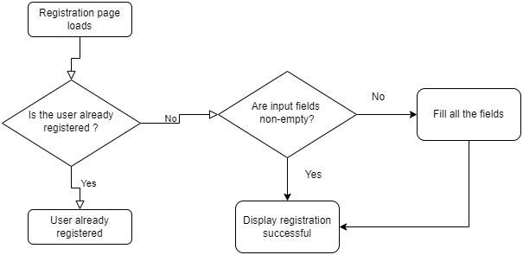

**Login**

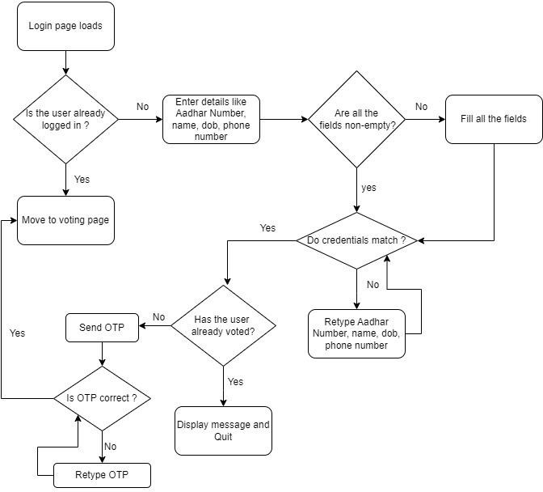

# SCREENSHOTS AND SOURCE

## Visual (Frontend)

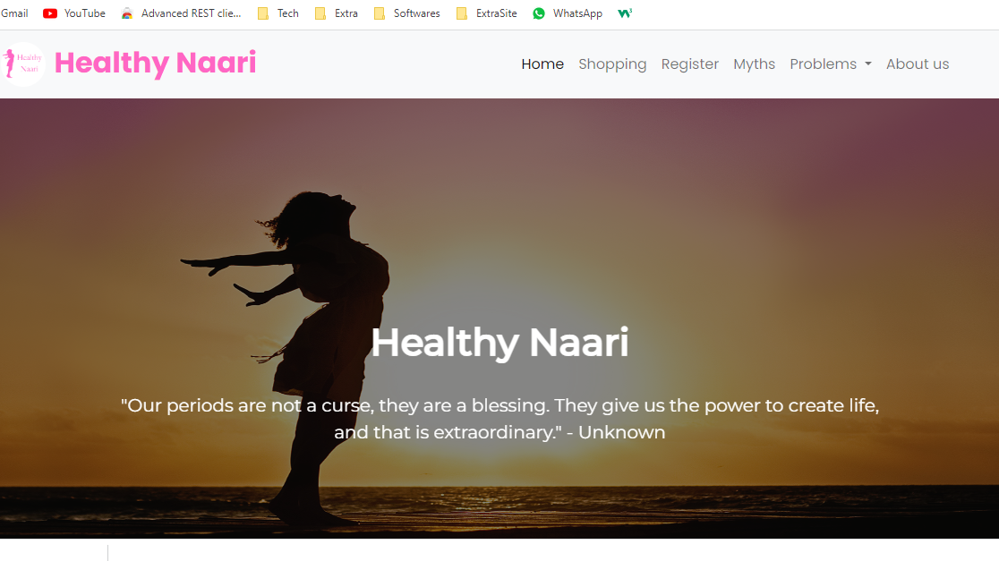

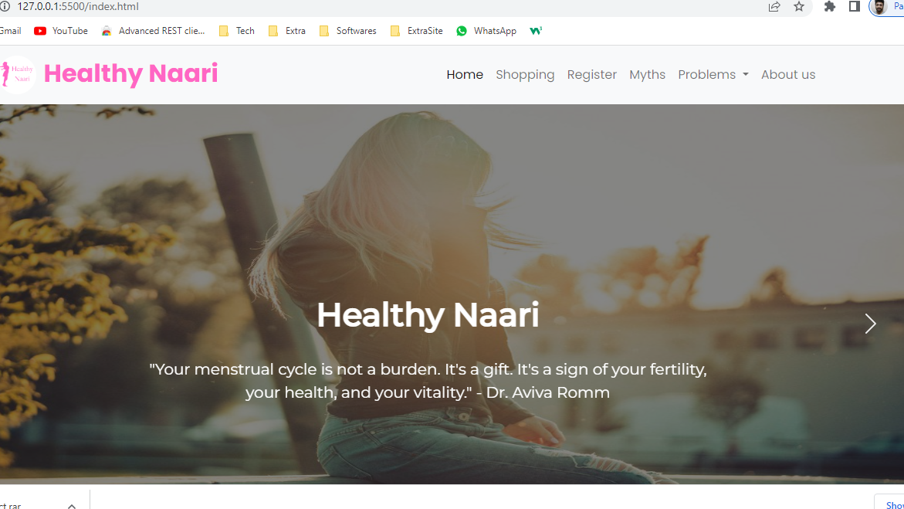

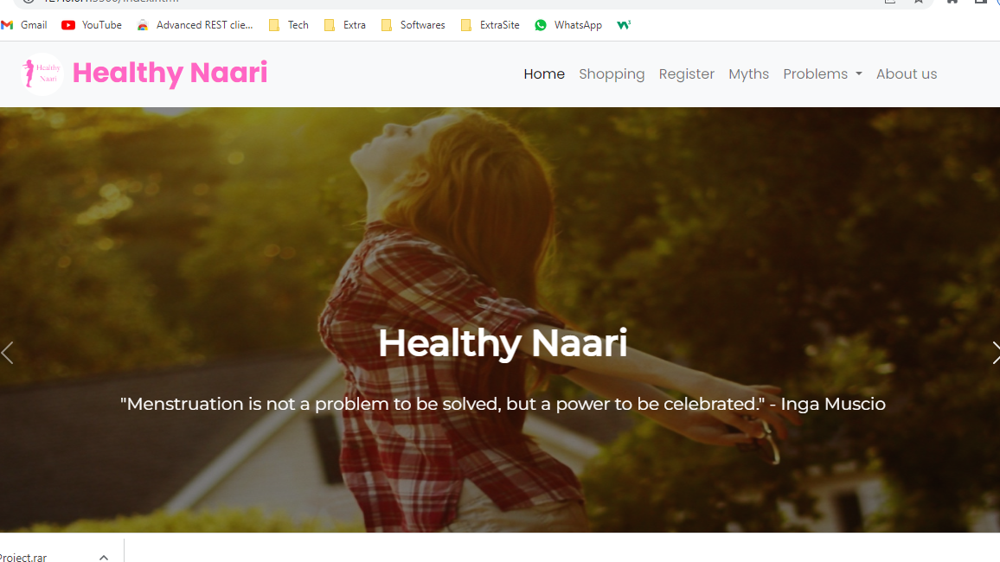

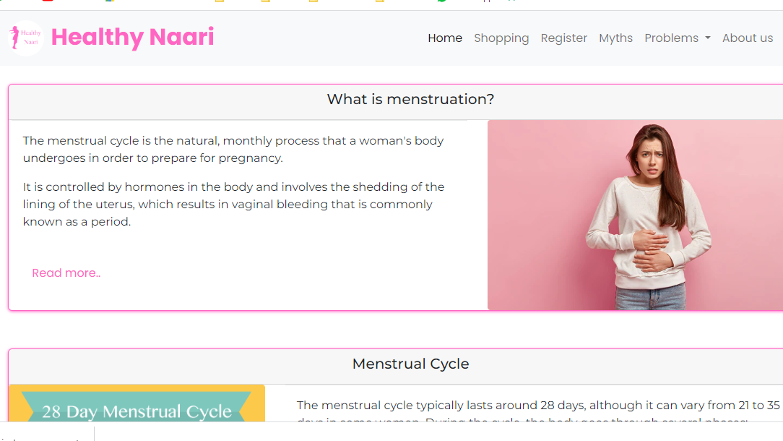

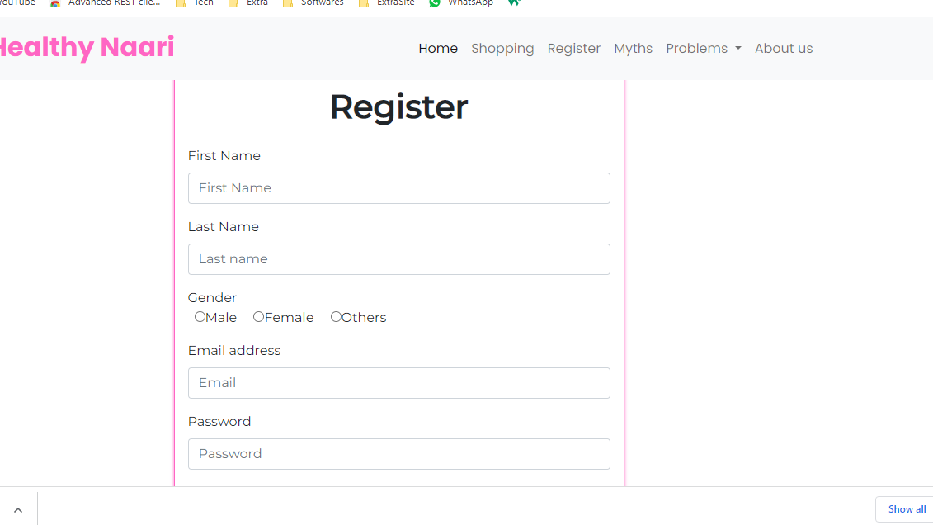

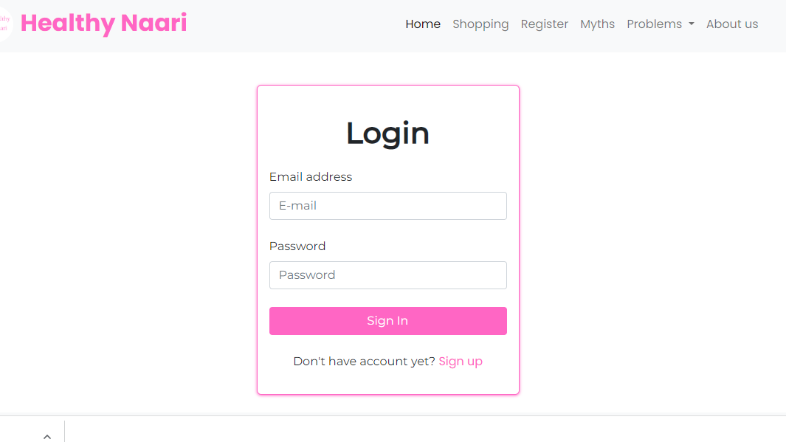

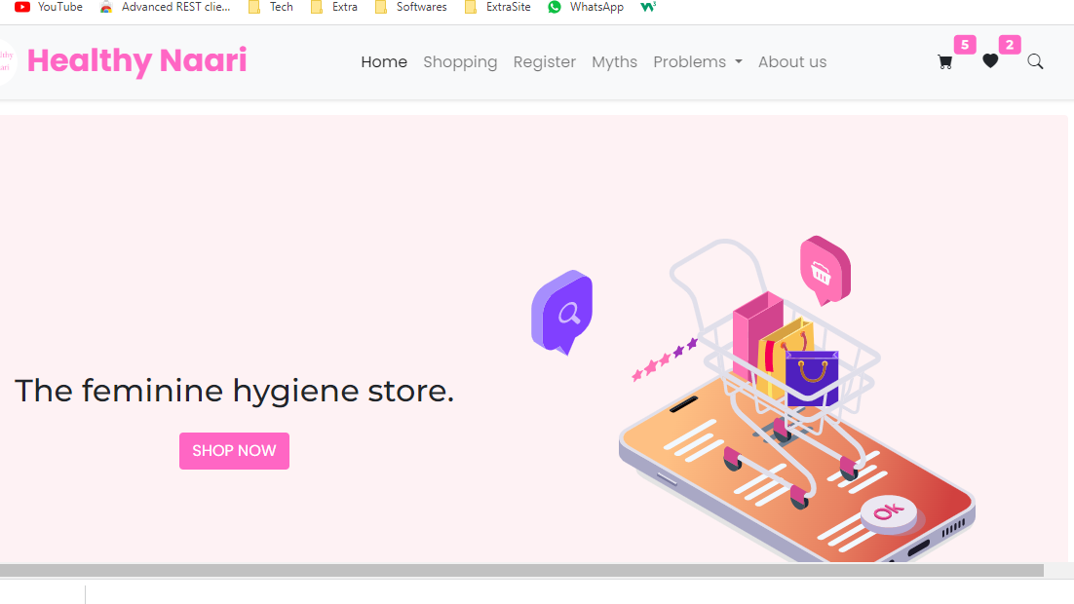

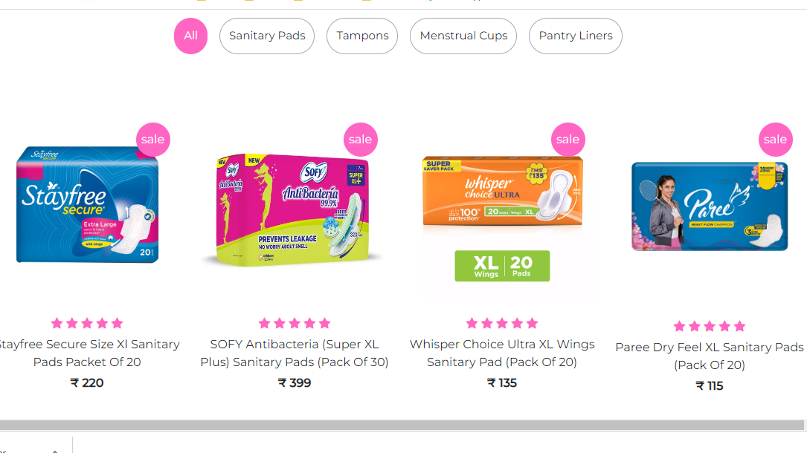

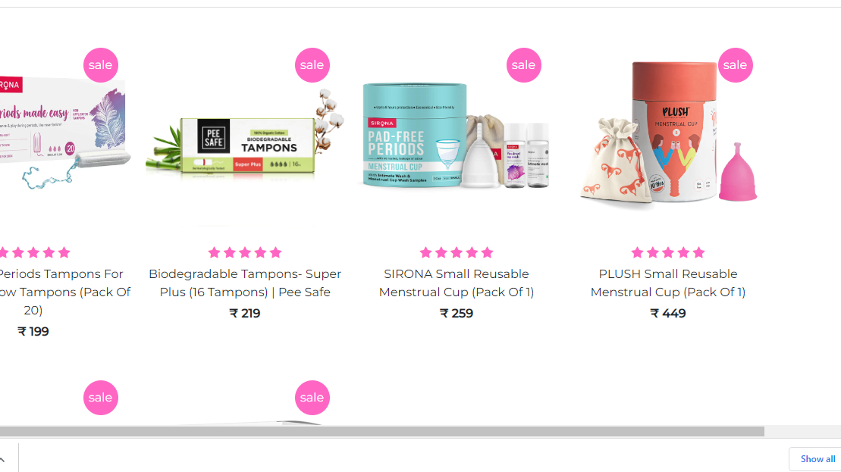

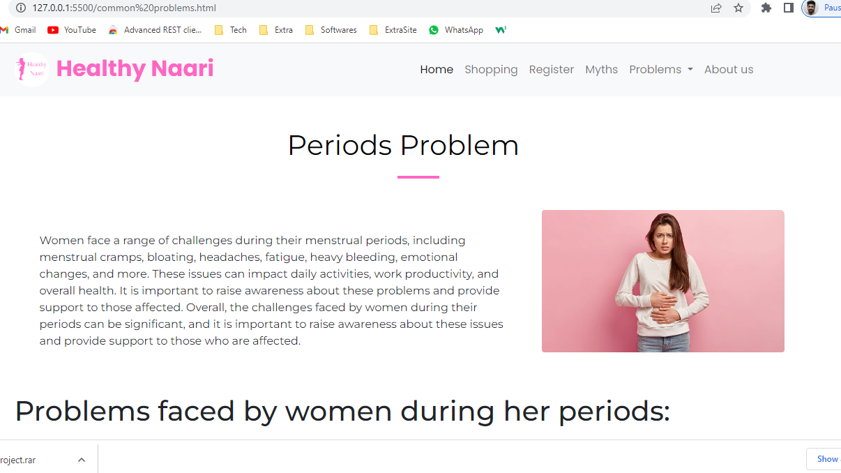

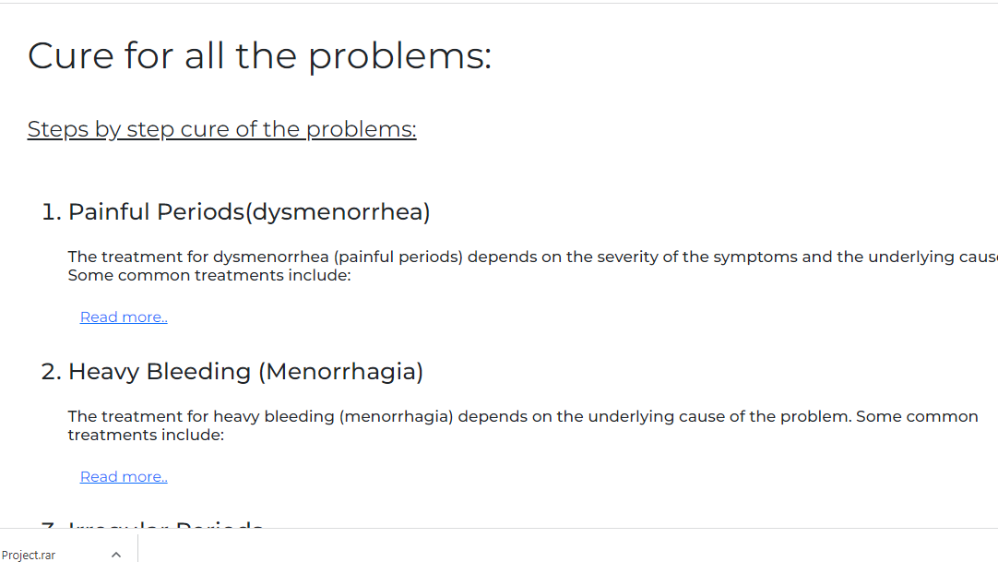

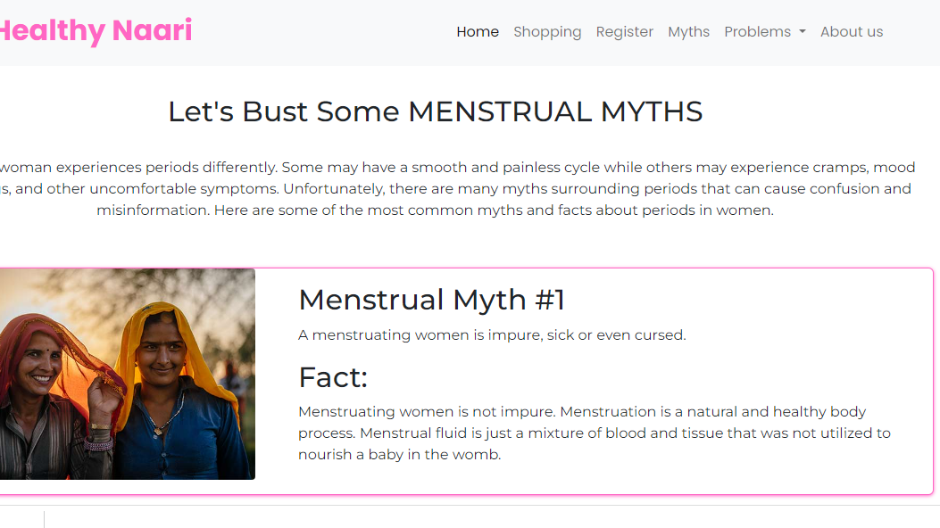

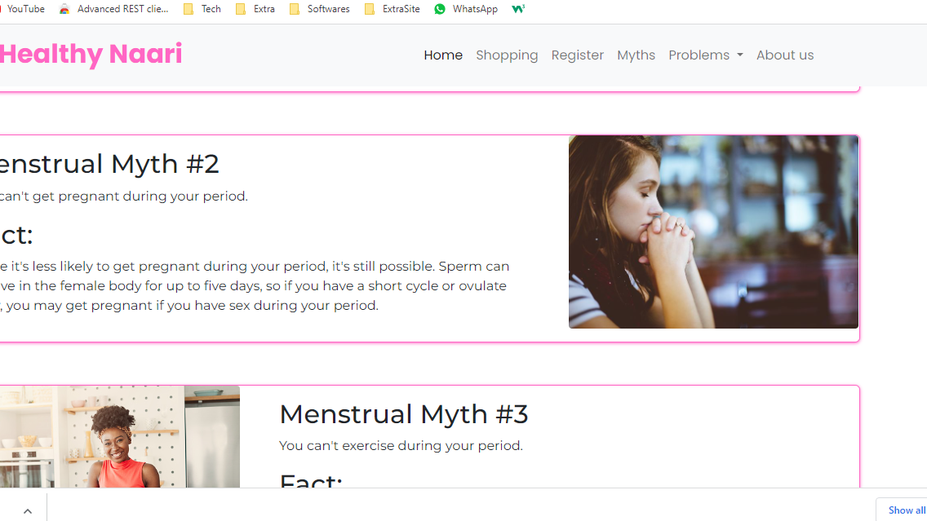



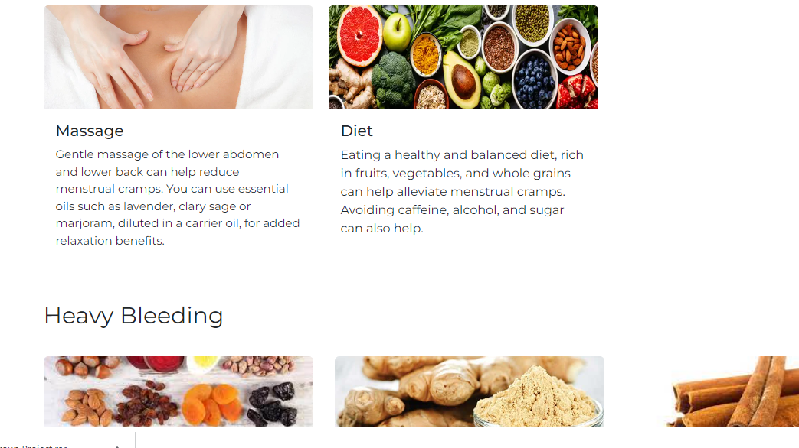

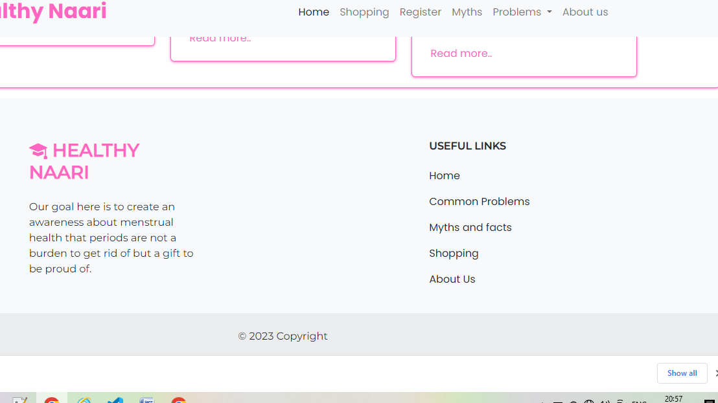

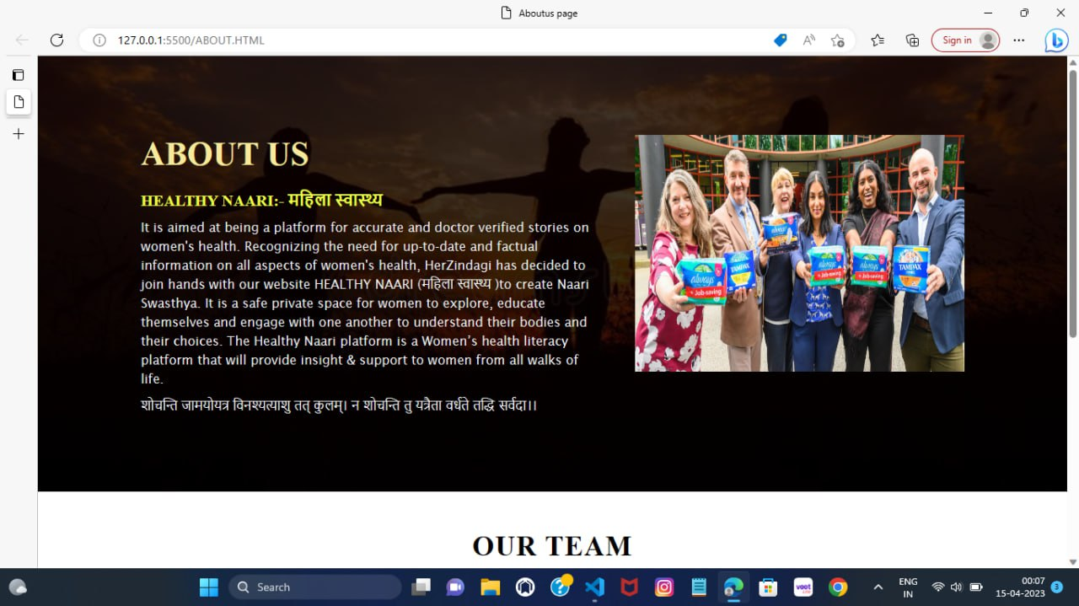

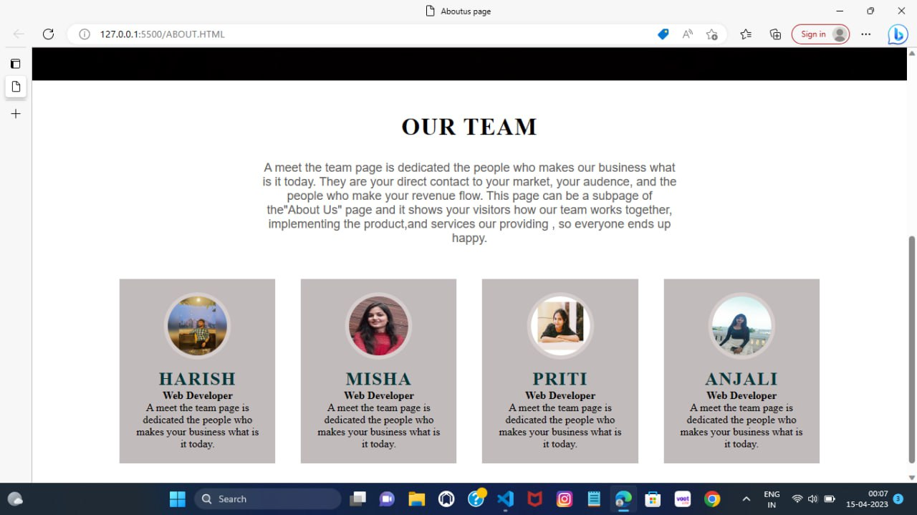

**Source Code (FRONTEND)**

**About Us.html**

<!DOCTYPE html>

<html lang="en">

<head>

    <meta charset="UTF-8">

    <meta http-equiv="X-UA-Compatible" contact="IE=edge">

    <meta name="viewpart" content="width=device-width,initial-scale=1.0">

    <title>Aboutus page</title>

    <link rel="stylesheet" href="style about.css">

    <link rel="stylesheet" href="styleteam1.css">

</head>

<body>

    <section>

     <div class="section1">

        <div class="containers">

            <div class="content-section">

                <div class="title">

                    <h1>About Us</h1>

                </div>

                <div class="content">

                    <h3>HEALTHY NAARI:- महिला स्वास्थ्य

                    </h3>

                    <p > It is aimed at being a platform for accurate and doctor verified stories on women's health. Recognizing the need for up-to-date and factual information on all aspects of women's health, HerZindagi has decided to join hands with our website HEALTHY NAARI (महिला स्वास्थ्य )to create Naari Swasthya.

                        It is a safe private space for women to explore, educate themselves and engage with one another to understand their bodies and their choices. The Healthy Naari platform is a Women’s health literacy platform that will provide insight & support to women from all walks of life.

                    </p>

                    <p>शोचन्ति जामयोयत्र विनश्यत्याशु तत् कुलम्।

                        न शोचन्ति तु यत्रैता वर्धते तद्धि सर्वदा।।</p>

                </div>

            </div>

           <div class="image-section">

            <style>

                *{

                    margin: 0;

                    padding: 0;

                    box-sizing: border-box;

                }

        body{

            width: 100%;

            height: 100vh;

            display: grid;

            place-items: center;

        }

        .slider

        {

            width: 100%;

            height: 300px;

            background-image: url("images/image5.jpg");

            background-size: 100% 100%;

            animation: slide 15s infinite;

        }

        @keyframes slide{

            0%{

                background-image: url("images/w1.jpeg");

            }

            25%{

                background-image: url("images/w4.jpeg");

            }

            50%{

                background-image: url("images/w8.jpeg");

            }

            75%{

                background-image: url("images/w2.jpeg");

            }

            100%{

                background-image: url("images/w7.jpeg");

            }

        }

            </style>

            <body>

                <div class="slider">

                </div>

            </body>

           </div>

        </div>

     </div>

    </section>

    <div class="section2">

        <body>

            <div class="team-section">

               <div class="container">

                   <div class="row">

                       <div class="title">

                           <h1>Our Team</h1>

                           <p>A meet the team page is dedicated the people who makes our business what is it today.

                               They are your direct contact to your market, your audence, and the people who make your revenue flow.

                               This page can be a subpage of the"About Us" page and it shows your visitors how our team works together,

                               implementing the product,and services our providing , so everyone ends up happy.

                           </p>

                       </div>

                   </div>

                   <div class="team-card">

                       <div class="card">

                           <div class="images-section">

                               <img src="images/harish.jpg">

                           </div>

                           <div class="contents">

                               <h3>HARISH</h3>

                               <h4>Web Developer</h4>

                               <P>A meet the team page is dedicated the people who makes your business what is it today.</P>

                           </div>

                       </div>

                       <div class="card">

                           <div class="images-section">

                               <img src="images/misha.jpg">

                           </div>

                           <div class="contents">

                               <h3>MISHA</h3>

                               <h4>Web Developer</h4>

                               <P>A meet the team page is dedicated the people who makes your business what is it today.</P>

                           </div>

                       </div>

                       <div class="card">

                           <div class="images-section">

                               <img src="images0.jpg">

                           </div>

                           <div class="contents">

                               <h3>PRITI</h3>

                               <h4>Web Developer</h4>

                               <P>A meet the team page is dedicated the people who makes your business what is it today.</P>

                           </div>

                       </div>

                       <div class="card">

                           <div class="images-section">

                               <img src="images/anjali.jpg">

                           </div>

                           <div class="contents">

                               <h3>ANJALI</h3>

                               <h4>Web Developer</h4>

                               <P>A meet the team page is dedicated the people who makes your business what is it today.</P>

                           </div>

                       </div>

                       </div>

                   </div>

               </div>

            </div>

       </body>

    </div>

    </body>

</html

## Index.html

<!DOCTYPE html>

<html lang="en">

<head>

    <meta charset="UTF-8">

    <meta http-equiv="X-UA-Compatible" content="IE=edge">

    <meta name="viewport" content="width=, initial-scale=1.0">

    <link href="https://cdn.jsdelivr.net/npm/bootstrap@5.0.2/dist/css/bootstrap.min.css" rel="stylesheet" integrity="sha384-EVSTQN3/azprG1Anm3QDgpJLIm9Nao0Yz1ztcQTwFspd3yD65VohhpuuCOmLASjC" crossorigin="anonymous">

    <link rel="stylesheet" href="https://cdnjs.cloudflare.com/ajax/libs/bootstrap-icons/1.8.3/font/bootstrap-icons.min.css">

    <link href="https://fonts.googleapis.com/css2?family=Poppins:ital,wght@0,100;0,200;0,300;0,400;0,500;0,600;0,700;0,800;0,900;1,100;1,200;1,300;1,400;1,500;1,600;1,700;1,800;1,900&display=swap" rel="stylesheet">

    <link rel="stylesheet" href="style.css">

    <title>Healthy Naari</title>

</head>

<body>

    <!-- <header>

        <section id="topbar" class="mb-2 mb-lg-0 mb-sm-0 d-none d-lg-flex align-items-center pt-2 pb-2 bg-primary text-white topbar-transparent">

            <div class="container">

                <div class="row">

                    <div class="col-lg-6   text-start">

                        <i class="bi bi-clock ms-auto"></i> Mon-Sat: 8:00 AM - 12:00 PM

                        <span class="px-3 ms-auto"><i class="bi bi-phone "></i> +91 6200377657 </span>

                    </div>

                </div>

            </div>

        </section> -->

    <nav class="navbar navbar-expand-lg navbar-light bg-light sticky-top">

        <div class="container">

            <a class="navbar-brand " href="index.html">

                <h2 class="fw-bold mb-2 mb-lg-0 mb-sm-0 logo"><img src="Images/Healthy Naari.png" class="rounded-circle" width="50px" height="50px" style="margin-right: 10px;">Healthy Naari</h2>

            </a>

            <button class="navbar-toggler" type="button" data-bs-toggle="collapse" data-bs-target="#navbarSupportedContent" aria-controls="navbarSupportedContent" aria-expanded="false" aria-label="Toggle navigation">

                <span class="bi bi-list"></span>

            </button>

            <div class="collapse navbar-collapse" id="navbarSupportedContent">

                <ul class="navbar-nav ms-auto me-lg-5 mb-2 mb-lg-0 list">

                    <li class="nav-item">

                        <a class="nav-link active" aria-current="page" href="index.html">Home</a>

                    </li>

                    <li class="nav-item">

                        <a class="nav-link" href="shopping.html">Shopping</a>

                    </li>

                    <li class="nav-item">

                        <a class="nav-link" href="register.html">Register</a>

                    </li>

                    <li class="nav-item">

                        <a class="nav-link" href="Myths and Facts.html">Myths</a>

                    </li>

                    <!-- <li class="nav-item">

                        <a class="nav-link" href="common problems.html">Problems</a>

                    </li> -->

                    <li class="nav-item dropdown">

                        <a class="nav-link dropdown-toggle" href="#" id="navbarDropdown" role="button" data-bs-toggle="dropdown" aria-haspopup="true" aria-expanded="false">

                          Problems

                        </a>

                        <div class="dropdown-menu" aria-labelledby="navbarDropdown">

                            <a class="dropdown-item" href="common problems.html">Common Problems</a>

                            <a class="dropdown-item" href="home remedies.html">Home Remedies</a>

                        </div>

                    </li>

                    <li class="nav-item">

                        <a class="nav-link" href="about.html">About us</a>

                    </li>

                </ul>

                <!-- <ul class="navbar-nav mb-2 mb-lg-0 action-menu">

                    <li class="nav-item">

                        <a class="nav-link " href="login.html">

                            <i class="bi bi-person "></i>

                        </a>

                    </li>

                </ul> -->

            </div>

        </div>

    </nav>

    </header>

    <div id="carouselExampleCaptions" class="carousel slide mb-3" data-bs-ride="carousel">

        <div class="carousel-indicators">

            <button type="button" data-bs-target="#carouselExampleCaptions" data-bs-slide-to="0" class="active" aria-current="true" aria-label="Slide 1"></button>

            <button type="button" data-bs-target="#carouselExampleCaptions" data-bs-slide-to="1" aria-label="Slide 2"></button>

            <button type="button" data-bs-target="#carouselExampleCaptions" data-bs-slide-to="2" aria-label="Slide 3"></button>

        </div>

        <div class="carousel-inner">

            <div class="carousel-item active">

                <img class="img-fluid w-100 h-100 overflow-hidden" src="Images/Healthy1.png" class="d-block w-100" alt="...">

                <div class="carousel-caption d-block">

                    <!-- <img src="Baby STAR PLAY (1).png" class="rounded-circle" width="80px" height="80px" style="margin-right: 10px;"> -->

                    <h5>Healthy Naari</h5>

                    <p>"Our periods are not a curse, they are a blessing. They give us the power to create life, <br>and that is extraordinary." - Unknown</p>

                    <!-- <a class="btn btn-primary btn-lg" href="register.html" role="button">Enroll Now</a> -->

                </div>

            </div>

            <div class="carousel-item">

                <img class="img-fluid w-100 h-100 overflow-hidden" src="Images/Healthy2.jpeg" class="d-block w-100" alt="...">

                <div class="carousel-caption d-block">

                    <h5>Healthy Naari</h5>

                    <p>"Your menstrual cycle is not a burden. It's a gift. It's a sign of your fertility,<br> your health, and your vitality." - Dr. Aviva Romm</p>

                    <!-- <a class="btn btn-primary btn-lg" href="register.html" role="button">Enroll Now</a> -->

                </div>

            </div>

            <div class="carousel-item">

                <img class="img-fluid w-100 h-100 overflow-hidden" src="Images/Healthy3.jpg" class="d-block w-100" alt="...">

                <div class="carousel-caption d-block">

                    <h5>Healthy Naari</h5>

                    <p>"Menstruation is not a problem to be solved, but a power to be celebrated." - Inga Muscio</p>

                    <!-- <a class="btn btn-primary btn-lg" href="register.html" role="button">Enroll Now</a> -->

                </div>

            </div>

        </div>

        <button class="carousel-control-prev" type="button" data-bs-target="#carouselExampleCaptions" data-bs-slide="prev">

        <span class="carousel-control-prev-icon" aria-hidden="true"></span>

        <span class="visually-hidden">Previous</span>

    </button>

        <button class="carousel-control-next" type="button" data-bs-target="#carouselExampleCaptions" data-bs-slide="next">

        <span class="carousel-control-next-icon" aria-hidden="true"></span>

        <span class="visually-hidden">Next</span>

    </button>

    </div>

    <div class="container py-3">

        <div class="card intro">

            <div class="card-header text-center">

                <h5> What is menstruation? </h5>

            </div>

            <div class="row ">

                <div class="col-md-7 px-3">

                    <div class="card-block px-6">

                        <p class="card-text">

                            The menstrual cycle is the natural, monthly process that a woman's body undergoes in order to prepare for pregnancy.

                        </p>

                        <p class="card-text">It is controlled by hormones in the body and involves the shedding of the lining of the uterus, which results in vaginal bleeding that is commonly known as a period.</p>

                        <br>

                        <a href="#" class="btn" style="color: #FF66C4;">Read more..</a>

                    </div>

                </div>

                <div class="col-md-5">

                    <img src="Images/women2.jpeg" class="img-fluid rounded-start rounded-end" alt="...">

                </div>

            </div>

        </div>

    </div>

    <!-- <div class="card-footer text-muted">

    </div>

    </div>

    <div class="detailsPopup" id="detailsPopup" style="display : none">

        <div class="close-btn">

            <button value="close" onclick="showdetails(0)">[ X ]</button>

        </div>

        <div class="details-body">

            <p>Lorem ipsum dolor sit amet consectetur, adipisicing elit. Aliquam assumenda, esse voluptate doloremque recusandae suscipit deserunt quia tempora quo nobis?</p>

        </div>

    </div> -->

    <div class="container py-3">

        <div class="card intro">

            <div class="card-header text-center">

                <h5> Menstrual Cycle</h5>

            </div>

            <div class="row ">

                <div class="col-md-4">

                    <img src="Images/cycle.jpeg" class="img-fluid rounded-start rounded-end" alt="...">

                </div>

                <div class="col-md-8 px-3">

                    <div class="card-block px-6">

                        <p class="card-text">

                            The menstrual cycle typically lasts around 28 days, although it can vary from 21 to 35 days in some women. During the cycle, the body goes through several phases:

                        </p>

                        <p class="card-text">

                            <ul>

                                <li><strong>Menstrual Phase: </strong>This is the phase where the uterus sheds its lining, which results in vaginal bleeding. It typically lasts for 3 to 7 days.</li>

                                <br>

                                <li><strong>Follicular Phase:</strong> This phase begins after the menstrual phase and lasts for around 14 days. During this phase, hormones in the body cause the ovaries to produce and mature an egg. </li>

                                <br>

                                <li><strong>Ovulation:</strong> This is the point in the cycle where the matured egg is released from the ovary and travels down the fallopian tube towards the uterus. This usually occurs around day 14 of a 28-day cycle.</li>

                                <br>

                                <li><strong>Luteal Phase:</strong> After ovulation, the empty follicle on the ovary where the egg was released produces the hormone progesterone. This hormone causes the lining of the uterus to thicken in preparation for a

                                    fertilized egg to implant. If the egg is not fertilized, the hormone levels drop and the lining of the uterus is shed, starting a new menstrual cycle.</li>

                            </ul>

                        </p>

                        <br>

                        <a href="#" class="btn" style="color: #FF66C4;">Read more..</a>

                    </div>

                </div>

            </div>

        </div>

    </div>

    <br>

    <div class="box py-3">

        <div class="card intro">

            <div class="card-header text-center">

                <h5> Problems faced in rural areas</h5>

            </div>

            <div class="container">

                <div class="row m-auto">

                    <div class="col-md-4 border-light ">

                        <div class="card text-bg-light mb-3" style="max-width: 30rem;">

                            <div class="card-body">

                                <h5 class="card-title card-header">High rate of illiteracy:</h5>

                                <p class="card-text">According to a survey conducted by government of India, it has been found that less than 18 per cent of Indian women use sanitary pads.

                                </p>

                                <a href="#" class="btn" style="color: #FF66C4;">Read more..</a>

                            </div>

                        </div>

                    </div>

                    <div class="col-md-4 border-light">

                        <div class="card text-bg-light" style="max-width: 30rem;">

                            <div class="card-body">

                                <h5 class="card-title card-header">Lack of access to information:</h5>

                                <p class="card-text">In India it has been found that, only 48% of adolescent girls are aware of what menstruation is before getting their first period. </p>

                                <a href="#" class="btn" style="color: #FF66C4;">Read more..</a>

                            </div>

                        </div>

                    </div>

                    <div class="col-md-4 border-light mb-3">

                        <div class="card text-bg-light" style="max-width: 30rem;">

                            <div class="card-body">

                                <h5 class="card-title card-header">Lack of access to information:</h5>

                                <p class="card-text">According to the (NFHS-4) in 2015-16, half the women in rural India (52%) do not use hygienic methods of protection during their menstrual period in India.</p>

                                <a href="#" class="btn" style="color: #FF66C4;">Read more..</a>

                            </div>

                        </div>

                    </div>

                </div>

            </div>

        </div>

    </div>

    <footer class="text-center text-lg-start bg-light py-3 text-dark">

        <section class="">

            <div class="container text-center text-md-start mt-5">

                <div class="row mt-3">

                    <div class="col-md-3 col-lg-4 col-xl-3 mx-auto mb-4">

                        <h3 class="text-uppercase fw-bold mb-4" style="color: #FF66C4;">

                            <i class="bi bi-mortarboard-fill me-2"></i>Healthy Naari

                        </h3>

                        <p>

                            Our goal here is to create an awareness about menstrual health that periods are not a burden to get rid of but a gift to be proud of.

                        </p>

                    </div>

                    <div class="col-md-3 col-lg-2 col-xl-2 mx-auto mb-4">

                        <h6 class="text-uppercase fw-bold mb-4">

                            Useful links

                        </h6>

                        <p>

                            <a href="index.html" class="text-reset">Home</a>

                        </p>

                        <p>

                            <a href="common problems.html" class="text-reset">Common Problems</a>

                        </p>

                        <p>

                            <a href="Myths and Facts.html" class="text-reset">Myths and facts</a>

                        </p>

                        <p>

                            <a href="shopping.html" class="text-reset">Shopping</a>

                        </p>

                        <p>

                            <a href="about.html" class="text-reset">About Us</a>

                        </p>

                    </div>

                    <!-- <div class="col-md-4 col-lg-3 col-xl-3 mx-auto mb-md-0 mb-4">

                        <h6 class="text-uppercase fw-bold mb-4">

                            Contact

                        </h6>

                        <p><i class="bi bi-geo-alt-fill me-3"></i> Baby Star Play School, Shantinagar, Samlong , Ranchi-834010</p>

                        <p>

                            <i class="bi bi-envelope me-3"></i>harish654@hotmail.com</a>

                        </p>

                        <p><i class="bi bi-phone me-3"></i>+91 7171717171</p>

                        <p><i class="bi bi-print me-3"></i> +91 8181818181</p>

                    </div> -->

                </div>

            </div>

        </section>

        <div class="text-center py-4" style="background-color: rgba(0, 0, 0, 0.05);">

            © 2023 Copyright

            <!-- <a class="text-reset fw-bold" href="https://mdbootstrap.com/">MDBootstrap.com</a> -->

        </div>

    </footer>

    <script src="https://cdn.jsdelivr.net/npm/bootstrap@5.0.2/dist/js/bootstrap.bundle.min.js" integrity="sha384-MrcW6ZMFYlzcLA8Nl+NtUVF0sA7MsXsP1UyJoMp4YLEuNSfAP+JcXn/tWtIaxVXM" crossorigin="anonymous"></script>

    <script src="popup.js"></script>

</body>

</html>

## Login.html

<!DOCTYPE html>

<html lang="en">

<head>

    <meta charset="UTF-8">

    <meta http-equiv="X-UA-Compatible" content="IE=edge">

    <meta name="viewport" content="width=, initial-scale=1.0">

    <link href="https://cdn.jsdelivr.net/npm/bootstrap@5.0.2/dist/css/bootstrap.min.css" rel="stylesheet" integrity="sha384-EVSTQN3/azprG1Anm3QDgpJLIm9Nao0Yz1ztcQTwFspd3yD65VohhpuuCOmLASjC" crossorigin="anonymous">

    <link rel="stylesheet" href="https://cdnjs.cloudflare.com/ajax/libs/bootstrap-icons/1.8.3/font/bootstrap-icons.min.css">

    <link href="https://fonts.googleapis.com/css2?family=Poppins:ital,wght@0,100;0,200;0,300;0,400;0,500;0,600;0,700;0,800;0,900;1,100;1,200;1,300;1,400;1,500;1,600;1,700;1,800;1,900&display=swap" rel="stylesheet">

    <link rel="stylesheet" href="style.css">

    <title>Healthy Naari</title>

</head>

<body>

    <!-- <header>

        <section id="topbar" class="mb-2 mb-lg-0 mb-sm-0 d-none d-lg-flex align-items-center pt-2 pb-2 bg-primary text-white topbar-transparent">

            <div class="container">

                <div class="row">

                    <div class="col-lg-6   text-start">

                        <i class="bi bi-clock ms-auto"></i> Mon-Sat: 8:00 AM - 12:00 PM

                        <span class="px-3 ms-auto"><i class="bi bi-phone "></i> +91 6200377657 </span>

                    </div>

                </div>

            </div>

        </section> -->

    <nav class="navbar navbar-expand-lg navbar-light bg-light h-50 sticky-top">

        <div class="container">

            <a class="navbar-brand " href="index.html">

                <h2 class="fw-bold mb-2 mb-lg-0 mb-sm-0 logo"><img src="Images/Healthy Naari.png" class="rounded-circle" width="50px" height="50px" style="margin-right: 10px;">Healthy Naari</h2>

            </a>

            <button class="navbar-toggler" type="button" data-bs-toggle="collapse" data-bs-target="#navbarSupportedContent" aria-controls="navbarSupportedContent" aria-expanded="false" aria-label="Toggle navigation">

                <span class="bi bi-list"></span>

            </button>

            <div class="collapse navbar-collapse" id="navbarSupportedContent">

                <ul class="navbar-nav ms-auto me-lg-5 mb-2 mb-lg-0 list">

                    <li class="nav-item">

                        <a class="nav-link active" aria-current="page" href="index.html">Home</a>

                    </li>

                    <li class="nav-item">

                        <a class="nav-link" href="shopping.html">Shopping</a>

                    </li>

                    <li class="nav-item">

                        <a class="nav-link" href="register.html">Register</a>

                    </li>

                    <li class="nav-item">

                        <a class="nav-link" href="Myths and Facts.html">Myths</a>

                    </li>

                    <!-- <li class="nav-item">

                        <a class="nav-link" href="common problems.html">Problems</a>

                    </li> -->

                    <li class="nav-item dropdown">

                        <a class="nav-link dropdown-toggle" href="#" id="navbarDropdown" role="button" data-bs-toggle="dropdown" aria-haspopup="true" aria-expanded="false">

                          Problems

                        </a>

                        <div class="dropdown-menu" aria-labelledby="navbarDropdown">

                            <a class="dropdown-item" href="common problems.html">Common Problems</a>

                            <a class="dropdown-item" href="home remedies.html">Home Remedies</a>

                        </div>

                    </li>

                    <li class="nav-item">

                        <a class="nav-link" href="about.html">About us</a>

                    </li>

                </ul>

                <!-- <ul class="navbar-nav mb-2 mb-lg-0 action-menu">

                    <li class="nav-item">

                        <a class="nav-link " href="login.html">

                            <i class="bi bi-person "></i>

                        </a>

                    </li>

                </ul> -->

            </div>

        </div>

    </nav>

    </header>

    <div class="container login-form mb-4" id="loginForm">

        <div class="row mt-4 justify-content-center">

            <div class="col-md-4">

                <div class="card">

                    <div class="card-body">

                        <div class="offest-md-4">

                            <div id="logH">

                                <h1 class="text-center mt-4 mb-4 fw-bolder">Login</h1>

                            </div>

                            <div id="regH" style="display: none;">

                                <h1 class="text-center mt-4 mb-4 fw-bolder">Register</h1>

                            </div>

                            <form action="login.php" method="post">

                                <div class="form-outline mb-4">

                                    <label class="form-label" for="email">Email address</label>

                                    <input type="email" id="email" class="form-control" name="email" placeholder="E-mail" required />

                                </div>

                                <div class="form-outline mb-4">

                                    <label class="form-label " for="password">Password</label>

                                    <input type="password" id="password" class="form-control" name="password" placeholder="Password" required />

                                </div>

                                <div class="">

                                    <button type="submit" class="col-12 btn button mb-4 btn-block" style="color: white;">Sign In</button>

                                </div>

                                <p class="text-center"> Don't have account yet?<a href="register.html" class="" style="color: #FF66C4;"> Sign up</a></p>

                            </form>

                        </div>

                    </div>

                </div>

            </div>

        </div>

    </div>

    <div class="container login-form" id="regForm" style="display: none;">

        <div class="row mt-4 justify-content-center">

            <div class="col-md-4">

                <div class="card">

                    <div class="card-body">

                        <div class="offest-md-4">

                            <h1 class="text-center mt-4 mb-4 fw-bolder">Register</h1>

                            <div class="form-outline mb-4">

                                <label class="form-label" for="form2Example1">Email address</label>

                                <input type="email" id="email2" class="form-control" placeholder="Email" />

                            </div>

                            <div class="form-outline mb-4">

                                <label class="form-label " for="form2Example2">Password</label>

                                <input type="password" id="password1" class="form-control" placeholder="Password" />

                            </div>

                            <div class="form-outline mb-4">

                                <label class="form-label " for="form2Example2">Confirm Password</label>

                                <input type="password" id="password2" class="form-control" placeholder="Confirm Password" />

                            </div>

                            <div class="row mb-4">

                                <div class="col d-flex">

                                    <div class="form-check">

                                        <input class="form-check-input" type="checkbox" value="" id="form2Example31" checked />

                                        <label class="form-check-label" for="form2Example31"> Remember me </label>

                                    </div>

                                </div>

                            </div>

                            <div class="">

                                <button type="button" id="sub_btn2" class="col-12 btn btn-primary btn-block mb-4">Create

                                    new

                                    Account</button>

                            </div>

                            <p class="text-center"> Already have account?<a href="#" onclick="GoToReg()" class="text-primary">

                                    Sign in</a></p>

                        </div>

                    </div>

                </div>

            </div>

        </div>

    </div>

    <script src="https://cdn.jsdelivr.net/npm/bootstrap@5.0.2/dist/js/bootstrap.bundle.min.js" integrity="sha384-MrcW6ZMFYlzcLA8Nl+NtUVF0sA7MsXsP1UyJoMp4YLEuNSfAP+JcXn/tWtIaxVXM" crossorigin="anonymous"></script>

    <footer class="text-center text-lg-start bg-light py-3 text-dark">

        <section class="">

            <div class="container text-center text-md-start mt-5">

                <div class="row mt-3">

                    <div class="col-md-3 col-lg-4 col-xl-3 mx-auto mb-4">

                        <h3 class="text-uppercase fw-bold mb-4" style="color: #FF66C4;">

                            <i class="bi bi-mortarboard-fill me-2"></i>Healthy Naari

                        </h3>

                        <p>

                            Our goal here is to create an awareness about menstrual health that periods are not a burden to get rid of but a gift to be proud of.

                        </p>

                    </div>

                    <div class="col-md-3 col-lg-2 col-xl-2 mx-auto mb-4">

                        <h6 class="text-uppercase fw-bold mb-4">

                            Useful links

                        </h6>

                        <p>

                            <a href="index.html" class="text-reset">Home</a>

                        </p>

                        <p>

                            <a href="common problems.html" class="text-reset">Common Problems</a>

                        </p>

                        <p>

                            <a href="Myths and Facts.html" class="text-reset">Myths and facts</a>

                        </p>

                        <p>

                            <a href="shopping.html" class="text-reset">Shopping</a>

                        </p>

                        <p>

                            <a href="about.html" class="text-reset">About Us</a>

                        </p>

                    </div>

                    <!-- <div class="col-md-4 col-lg-3 col-xl-3 mx-auto mb-md-0 mb-4">

                            <h6 class="text-uppercase fw-bold mb-4">

                                Contact

                            </h6>

                            <p><i class="bi bi-geo-alt-fill me-3"></i> Baby Star Play School, Shantinagar, Samlong , Ranchi-834010</p>

                            <p>

                                <i class="bi bi-envelope me-3"></i>harish654@hotmail.com</a>

                            </p>

                            <p><i class="bi bi-phone me-3"></i>+91 7171717171</p>

                            <p><i class="bi bi-print me-3"></i> +91 8181818181</p>

                        </div> -->

                </div>

            </div>

        </section>

        <div class="text-center py-4" style="background-color: rgba(0, 0, 0, 0.05);">

            © 2023 Copyright

            <!-- <a class="text-reset fw-bold" href="https://mdbootstrap.com/">MDBootstrap.com</a> -->

        </div>

    </footer>

    <script src="https://cdn.jsdelivr.net/npm/bootstrap@5.0.2/dist/js/bootstrap.bundle.min.js" integrity="sha384-MrcW6ZMFYlzcLA8Nl+NtUVF0sA7MsXsP1UyJoMp4YLEuNSfAP+JcXn/tWtIaxVXM" crossorigin="anonymous"></script>

    <script src="popup.js"></script>

</body>

</html>

## Register.html

<!DOCTYPE html>

<html lang="en">

<head>

    <meta charset="UTF-8">

    <meta http-equiv="X-UA-Compatible" content="IE=edge">

    <meta name="viewport" content="width=, initial-scale=1.0">

    <link href="https://cdn.jsdelivr.net/npm/bootstrap@5.0.2/dist/css/bootstrap.min.css" rel="stylesheet" integrity="sha384-EVSTQN3/azprG1Anm3QDgpJLIm9Nao0Yz1ztcQTwFspd3yD65VohhpuuCOmLASjC" crossorigin="anonymous">

    <link rel="stylesheet" href="https://cdnjs.cloudflare.com/ajax/libs/bootstrap-icons/1.8.3/font/bootstrap-icons.min.css">

    <link href="https://fonts.googleapis.com/css2?family=Poppins:ital,wght@0,100;0,200;0,300;0,400;0,500;0,600;0,700;0,800;0,900;1,100;1,200;1,300;1,400;1,500;1,600;1,700;1,800;1,900&display=swap" rel="stylesheet">

    <link rel="stylesheet" href="style.css">

    <title>Healthy Naari</title>

</head>

<body>

    <nav class="navbar navbar-expand-lg navbar-light bg-light h-50 sticky-top">

        <div class="container">

            <a class="navbar-brand " href="index.html">

                <h2 class="fw-bold mb-2 mb-lg-0 mb-sm-0 logo"><img src="Images/Healthy Naari.png" class="rounded-circle" width="50px" height="50px" style="margin-right: 10px;">Healthy Naari</h2>

            </a>

            <button class="navbar-toggler" type="button" data-bs-toggle="collapse" data-bs-target="#navbarSupportedContent" aria-controls="navbarSupportedContent" aria-expanded="false" aria-label="Toggle navigation">

                <span class="bi bi-list"></span>

            </button>

            <div class="collapse navbar-collapse" id="navbarSupportedContent">

                <ul class="navbar-nav ms-auto me-lg-5 mb-2 mb-lg-0 list">

                    <li class="nav-item">

                        <a class="nav-link active" aria-current="page" href="index.html">Home</a>

                    </li>

                    <li class="nav-item">

                        <a class="nav-link" href="shopping.html">Shopping</a>

                    </li>

                    <li class="nav-item">

                        <a class="nav-link" href="register.html">Register</a>

                    </li>

                    <li class="nav-item">

                        <a class="nav-link" href="Myths and Facts.html">Myths</a>

                    </li>

                    <!-- <li class="nav-item">

                        <a class="nav-link" href="common problems.html">Problems</a>

                    </li> -->

                    <li class="nav-item dropdown">

                        <a class="nav-link dropdown-toggle" href="#" id="navbarDropdown" role="button" data-bs-toggle="dropdown" aria-haspopup="true" aria-expanded="false">

                            Problems

                        </a>

                        <div class="dropdown-menu" aria-labelledby="navbarDropdown">

                            <a class="dropdown-item" href="common problems.html">Common Problems</a>

                            <a class="dropdown-item" href="home remedies.html">Home Remedies</a>

                        </div>

                    </li>

                    <li class="nav-item">

                        <a class="nav-link" href="about.html">About us</a>

                    </li>

                </ul>

                <!-- <ul class="navbar-nav mb-2 mb-lg-0 action-menu">

                    <li class="nav-item">

                        <a class="nav-link " href="login.html">

                            <i class="bi bi-person "></i>

                        </a>

                    </li>

                </ul> -->

            </div>

        </div>

    </nav>

    </header>

    <div class="container login-form mb-4" id="regForm">

        <div class="row mt-4 justify-content-center">

            <div class="col-md-6">

                <div class="card">

                    <div class="card-body">

                        <div class="offest-md-4">

                            <h1 class="text-center mt-4 mb-4 fw-bolder">Register</h1>

                            <form action="connect.php" method="post">

                                <div class="form-outline mb-3">

                                    <label class="form-label" for="fname">First Name</label>

                                    <input type="fname" id="fname" class="form-control" name="fname" placeholder="First Name" />

                                </div>

                                <div class="form-outline mb-3">

                                    <label class="form-label" for="lname">Last Name</label>

                                    <input type="lname" id="lname" class="form-control" name="lname" placeholder="Last name" />

                                </div>

                                <div class="form-group">

                                    <label for="gender">Gender</label>

                                    <div class="mb-3">

                                        <label for="male" class="radio-inline mx-2">

                                            <input type="radio" name="gender" value="m" id="male" />Male</label>

                                        <label for="female" class="radio-inline mx-2">

                                            <input type="radio" name="gender" value="f" id="female" />Female</label>

                                        <label for="others" class="radio-inline mx-2">

                                            <input type="radio" name="gender" value="o" id="others" />Others</label>

                                    </div>

                                    <div class="form-outline mb-3">

                                        <label class="form-label" for="email">Email address</label>

                                        <input type="email" id="email" class="form-control" name="email" placeholder="Email" />

                                    </div>

                                    <div class="form-outline mb-3">

                                        <label class="form-label" for="password">Password</label>

                                        <input type="password" id="password" class="form-control" name="password" placeholder="Password" />

                                    </div>

                                    <div class="form-outline mb-3">

                                        <label class="form-label " for="number">Phone Number</label>

                                        <input type="number" id="number" class="form-control" name="number" placeholder="Phone Number" />

                                    </div>

                                    <div class="">

                                        <button type="submit" class="col-12 btn button mb-4 btn-block" style="color: white;">Sign

                                            Up</button>

                                    </div>

                                    <p class="text-center"> Already have account?<a href="login.html" class="" style="color: #FF66C4;">

                                            Sign in</a></p>

                                </div>

                            </form>

                        </div>

                    </div>

                </div>

            </div>

        </div>

    </div>

    <script src="https://cdn.jsdelivr.net/npm/bootstrap@5.0.2/dist/js/bootstrap.bundle.min.js" integrity="sha384-MrcW6ZMFYlzcLA8Nl+NtUVF0sA7MsXsP1UyJoMp4YLEuNSfAP+JcXn/tWtIaxVXM" crossorigin="anonymous"></script>

    <footer class="text-center text-lg-start bg-light py-3 text-dark">

        <section class="">

            <div class="container text-center text-md-start mt-5">

                <div class="row mt-3">

                    <div class="col-md-3 col-lg-4 col-xl-3 mx-auto mb-4">

                        <h3 class="text-uppercase fw-bold mb-4" style="color: #FF66C4;">

                            <i class="bi bi-mortarboard-fill me-2"></i>Healthy Naari

                        </h3>

                        <p>

                            Our goal here is to create an awareness about menstrual health that periods are not a burden to get rid of but a gift to be proud of.

                        </p>

                    </div>

                    <div class="col-md-3 col-lg-2 col-xl-2 mx-auto mb-4">

                        <h6 class="text-uppercase fw-bold mb-4">

                            Useful links

                        </h6>

                        <p>

                            <a href="index.html" class="text-reset">Home</a>

                        </p>

                        <p>

                            <a href="common problems.html" class="text-reset">Common Problems</a>

                        </p>

                        <p>

                            <a href="Myths and Facts.html" class="text-reset">Myths and facts</a>

                        </p>

                        <p>

                            <a href="shopping.html" class="text-reset">Shopping</a>

                        </p>

                        <p>

                            <a href="about.html" class="text-reset">About Us</a>

                        </p>

                    </div>

                    <!-- <div class="col-md-4 col-lg-3 col-xl-3 mx-auto mb-md-0 mb-4">

                        <h6 class="text-uppercase fw-bold mb-4">

                            Contact

                        </h6>

                        <p><i class="bi bi-geo-alt-fill me-3"></i> Baby Star Play School, Shantinagar, Samlong , Ranchi-834010</p>

                        <p>

                            <i class="bi bi-envelope me-3"></i>harish654@hotmail.com</a>

                        </p>

                        <p><i class="bi bi-phone me-3"></i>+91 7171717171</p>

                        <p><i class="bi bi-print me-3"></i> +91 8181818181</p>

                    </div> -->

                </div>

            </div>

        </section>

        <div class="text-center py-4" style="background-color: rgba(0, 0, 0, 0.05);">

            © 2023 Copyright

            <!-- <a class="text-reset fw-bold" href="https://mdbootstrap.com/">MDBootstrap.com</a> -->

        </div>

    </footer>

    <script src="https://cdn.jsdelivr.net/npm/bootstrap@5.0.2/dist/js/bootstrap.bundle.min.js" integrity="sha384-MrcW6ZMFYlzcLA8Nl+NtUVF0sA7MsXsP1UyJoMp4YLEuNSfAP+JcXn/tWtIaxVXM" crossorigin="anonymous"></script>

    <script src="popup.js"></script>

</body>

</html>

## Myth and Facts.html

<!DOCTYPE html>

<html lang="en">

<head>

    <meta charset="UTF-8">

    <meta http-equiv="X-UA-Compatible" content="IE=edge">

    <meta name="viewport" content="width=, initial-scale=1.0">

    <link href="https://cdn.jsdelivr.net/npm/bootstrap@5.0.2/dist/css/bootstrap.min.css" rel="stylesheet" integrity="sha384-EVSTQN3/azprG1Anm3QDgpJLIm9Nao0Yz1ztcQTwFspd3yD65VohhpuuCOmLASjC" crossorigin="anonymous">

    <link rel="stylesheet" href="https://cdnjs.cloudflare.com/ajax/libs/bootstrap-icons/1.8.3/font/bootstrap-icons.min.css">

    <link href="https://fonts.googleapis.com/css2?family=Poppins:ital,wght@0,100;0,200;0,300;0,400;0,500;0,600;0,700;0,800;0,900;1,100;1,200;1,300;1,400;1,500;1,600;1,700;1,800;1,900&display=swap" rel="stylesheet">

    <link rel="stylesheet" href="style.css">

    <title>Healthy Naari</title>

</head>

<body>

    <!-- <header>

        <section id="topbar" class="mb-2 mb-lg-0 mb-sm-0 d-none d-lg-flex align-items-center pt-2 pb-2 bg-primary text-white topbar-transparent">

            <div class="container">

                <div class="row">

                    <div class="col-lg-6   text-start">

                        <i class="bi bi-clock ms-auto"></i> Mon-Sat: 8:00 AM - 12:00 PM

                        <span class="px-3 ms-auto"><i class="bi bi-phone "></i> +91 6200377657 </span>

                    </div>

                </div>

            </div>

        </section> -->

    <nav class="navbar navbar-expand-lg navbar-light bg-light h-50 sticky-top">

        <div class="container">

            <a class="navbar-brand " href="index.html">

                <h2 class="fw-bold mb-2 mb-lg-0 mb-sm-0 logo"><img src="Images/Healthy Naari.png" class="rounded-circle" width="50px" height="50px" style="margin-right: 10px;">Healthy Naari</h2>

            </a>

            <button class="navbar-toggler" type="button" data-bs-toggle="collapse" data-bs-target="#navbarSupportedContent" aria-controls="navbarSupportedContent" aria-expanded="false" aria-label="Toggle navigation">

                <span class="bi bi-list"></span>

            </button>

            <div class="collapse navbar-collapse" id="navbarSupportedContent">

                <ul class="navbar-nav ms-auto me-lg-5 mb-2 mb-lg-0 list">

                    <li class="nav-item">

                        <a class="nav-link active" aria-current="page" href="index.html">Home</a>

                    </li>

                    <li class="nav-item">

                        <a class="nav-link" href="shopping.html">Shopping</a>

                    </li>

                    <li class="nav-item">

                        <a class="nav-link" href="register.html">Register</a>

                    </li>

                    <li class="nav-item">

                        <a class="nav-link" href="Myths and Facts.html">Myths</a>

                    </li>

                    <li class="nav-item dropdown">

                        <a class="nav-link dropdown-toggle" href="#" id="navbarDropdown" role="button" data-bs-toggle="dropdown" aria-haspopup="true" aria-expanded="false">

                          Problems

                        </a>

                        <div class="dropdown-menu" aria-labelledby="navbarDropdown">

                            <a class="dropdown-item" href="common problems.html">Common Problems</a>

                            <a class="dropdown-item" href="home remedies.html">Home Remedies</a>

                        </div>

                    </li>

                    <li class="nav-item">

                        <a class="nav-link" href="about.html">About us</a>

                    </li>

                </ul>

                <!-- <ul class="navbar-nav mb-2 mb-lg-0 action-menu">

                    <li class="nav-item">

                        <a class="nav-link " href="login.html">

                            <i class="bi bi-person "></i>

                        </a>

                    </li>

                </ul> -->

            </div>

        </div>

    </nav>

    </header>

    <div class="container">

        <h2 class="text-center py-3 mt-3"> Let's Bust Some MENSTRUAL MYTHS</h2>

        <p class="text-center mt-3 font-weight-bold">Every woman experiences periods differently. Some may have a smooth and painless cycle while others may experience cramps, mood swings, and other uncomfortable symptoms. Unfortunately, there are many myths surrounding periods that can cause confusion

            and misinformation. Here are some of the most common myths and facts about periods in women.

        </p>

    </div>

    <div class="container py-3">

        <div class="card">

            <div class="row">

                <div class="col-md-4">

                    <img src="Images/Myth1.jpg" class="img-fluid rounded-start rounded-end" alt="...">

                </div>

                <div class="col-md-8">

                    <div class="container py-3">

                        <div class="row">

                            <div class="col-md-12">

                                <h2>Menstrual Myth #1</h2>

                                <p>A menstruating women is impure, sick or even cursed.</p>

                            </div>

                            <div class="col-md-12">

                                <h2>Fact:</h2>

                                <p>Menstruating women is not impure. Menstruation is a natural and healthy body process. Menstrual fluid is just a mixture of blood and tissue that was not utilized to nourish a baby in the womb.</p>

                                <!-- <a href="#" class="btn" style="color: #E384FF;">Read more..</a> -->

                            </div>

                        </div>

                    </div>

                </div>

            </div>

        </div>

    </div>

    <div class="container py-3">

        <div class="card">

            <div class="row">

                <div class="col-md-8">

                    <div class="container py-3">

                        <div class="row">

                            <div class="col-md-12">

                                <h2>Menstrual Myth #2</h2>

                                <p> You can't get pregnant during your period.</p>

                            </div>

                            <div class="col-md-12">

                                <h2>Fact:</h2>

                                <p> While it's less likely to get pregnant during your period, it's still possible. Sperm can survive in the female body for up to five days, so if you have a short cycle or ovulate early, you may get pregnant if you have sex

                                    during your period.</p>

                                <!-- <a href="#" class="btn" style="color: #E384FF;">Read more..</a> -->

                            </div>

                        </div>

                    </div>

                </div>

                <div class="col-md-4">

                    <img src="Images/Myth2_3.jpg" class="img-fluid rounded-start rounded-end" alt="...">

                </div>

            </div>

        </div>

    </div>

    <div class="container py-3">

        <div class="card">

            <div class="row">

                <div class="col-md-4">

                    <img src="Images/myth3_1.jpg" class="img-fluid rounded-start rounded-end" alt="...">

                </div>

                <div class="col-md-8">

                    <div class="container py-3">

                        <div class="row">

                            <div class="col-md-12">

                                <h2>Menstrual Myth #3</h2>

                                <p>You can't exercise during your period.</p>

                            </div>

                            <div class="col-md-12">

                                <h2>Fact:</h2>

                                <p>Exercise can actually help relieve menstrual cramps and boost your mood during your period. Low-impact exercises like yoga, swimming, and walking can be particularly helpful. Just make sure to use a tampon or menstrual

                                    cup if you're using a sanitary pad to avoid discomfort and leaks.</p>

                                <!-- <a href="#" class="btn" style="color: #E384FF;">Read more..</a> -->

                            </div>

                        </div>

                    </div>

                </div>

            </div>

        </div>

    </div>

    <div class="container py-3">

        <div class="card">

            <div class="row">

                <div class="col-md-8">

                    <div class="container py-3">

                        <div class="row">

                            <div class="col-md-12">

                                <h2>Menstrual Myth #4</h2>

                                <p>You should avoid certain foods during your period.</p>

                            </div>

                            <div class="col-md-12">

                                <h2>Fact:</h2>

                                <p>There's no scientific evidence to support the idea that you should avoid certain foods during your period. However, some women may find that certain foods like caffeine, alcohol, and salty foods can worsen their symptoms.

                                    It's important to listen to your body and eat a balanced, nutritious diet.</p>

                                <!-- <a href="#" class="btn" style="color: #E384FF;">Read more..</a> -->

                            </div>

                        </div>

                    </div>

                </div>

                <div class="col-md-4">

                    <img src="Images/Myth2_3.jpg" class="img-fluid rounded-start rounded-end" alt="...">

                </div>

            </div>

        </div>

    </div>

    <div class="container py-3">

        <div class="card">

            <div class="row">

                <div class="col-md-4">

                    <img src="Images/myth3_1.jpg" class="img-fluid rounded-start rounded-end" alt="...">

                </div>

                <div class="col-md-8">

                    <div class="container py-3">

                        <div class="row">

                            <div class="col-md-12">

                                <h2>Menstrual Myth #5</h2>

                                <p>Periods are always 28 days long.</p>

                            </div>

                            <div class="col-md-12">

                                <h2>Fact:</h2>

                                <p>EWhile the average menstrual cycle is around 28 days, it's normal for cycles to range from 21 to 35 days long. Some women may also experience irregular periods due to hormonal imbalances, stress, or other factors. If you're

                                    concerned about your menstrual cycle, talk to your healthcare provider.

                                </p>

                                <!-- <a href="#" class="btn" style="color: #E384FF;">Read more..</a> -->

                            </div>

                        </div>

                    </div>

                </div>

            </div>

        </div>

    </div>

    <div class="container py-3">

        <div class="card">

            <div class="row">

                <div class="col-md-8">

                    <div class="container py-3">

                        <div class="row">

                            <div class="col-md-12">

                                <h2>Menstrual Myth #6</h2>

                                <p>Using birth control can make it harder to get pregnant in the future.</p>

                            </div>

                            <div class="col-md-12">

                                <h2>Fact:</h2>

                                <p>Using birth control does not affect your ability to get pregnant in the future. In fact, some types of birth control like the hormonal IUD can even improve fertility after it's removed.</p>

                                <!-- <a href="#" class="btn" style="color: #E384FF;">Read more..</a> -->

                            </div>

                        </div>

                    </div>

                </div>

                <div class="col-md-4">

                    <img src="Images/Myth2_3.jpg" class="img-fluid rounded-start rounded-end" alt="...">

                </div>

            </div>

        </div>

    </div>

    <div class="container mb-5">

        <h2 class="text-center py-3 mt-3">Conclusion</h2>

        <p class="text-center mt-3 font-weight-bold w-auto mx-auto">Periods can be uncomfortable and inconvenient, but they're a normal part of life for most women. It's important to separate fact from fiction when it comes to menstrual health to avoid misinformation and confusion. If you have concerns about your

            period or menstrual health, talk to your healthcare provider.

        </p>

    </div>

    <footer class="text-center text-lg-start bg-light py-3 text-dark">

        <section class="">

            <div class="container text-center text-md-start mt-5">

                <div class="row mt-3">

                    <div class="col-md-3 col-lg-4 col-xl-3 mx-auto mb-4">

                        <h3 class="text-uppercase fw-bold mb-4" style="color: #FF66C4;">

                            <i class="bi bi-mortarboard-fill me-2"></i>Healthy Naari

                        </h3>

                        <p>

                            Our goal here is to create an awareness about menstrual health that periods are not a burden to get rid of but a gift to be proud of.

                        </p>

                    </div>

                    <div class="col-md-3 col-lg-2 col-xl-2 mx-auto mb-4">

                        <h6 class="text-uppercase fw-bold mb-4">

                            Useful links

                        </h6>

                        <p>

                            <a href="index.html" class="text-reset">Home</a>

                        </p>

                        <p>

                            <a href="common problems.html" class="text-reset">Common Problems</a>

                        </p>

                        <p>

                            <a href="Myths and Facts.html" class="text-reset">Myths and facts</a>

                        </p>

                        <p>

                            <a href="shopping.html" class="text-reset">Shopping</a>

                        </p>

                        <p>

                            <a href="about.html" class="text-reset">About Us</a>

                        </p>

                    </div>

                    <!-- <div class="col-md-4 col-lg-3 col-xl-3 mx-auto mb-md-0 mb-4">

                        <h6 class="text-uppercase fw-bold mb-4">

                            Contact

                        </h6>

                        <p><i class="bi bi-geo-alt-fill me-3"></i> Baby Star Play School, Shantinagar, Samlong , Ranchi-834010</p>

                        <p>

                            <i class="bi bi-envelope me-3"></i>harish654@hotmail.com</a>

                        </p>

                        <p><i class="bi bi-phone me-3"></i>+91 7171717171</p>

                        <p><i class="bi bi-print me-3"></i> +91 8181818181</p>

                    </div> -->

                </div>

            </div>

        </section>

        <div class="text-center py-4" style="background-color: rgba(0, 0, 0, 0.05);">

            © 2023 Copyright

            <!-- <a class="text-reset fw-bold" href="https://mdbootstrap.com/">MDBootstrap.com</a> -->

        </div>

    </footer>

    <script src="https://cdn.jsdelivr.net/npm/bootstrap@5.0.2/dist/js/bootstrap.bundle.min.js" integrity="sha384-MrcW6ZMFYlzcLA8Nl+NtUVF0sA7MsXsP1UyJoMp4YLEuNSfAP+JcXn/tWtIaxVXM" crossorigin="anonymous"></script>

    <script src="popup.js"></script>

</body>

</html>

## Common problems.html

<!DOCTYPE html>

<html lang="en">

<head>

    <meta charset="UTF-8">

    <meta http-equiv="X-UA-Compatible" content="IE=edge">

    <meta name="viewport" content="width=, initial-scale=1.0">

    <link href="https://cdn.jsdelivr.net/npm/bootstrap@5.0.2/dist/css/bootstrap.min.css" rel="stylesheet" integrity="sha384-EVSTQN3/azprG1Anm3QDgpJLIm9Nao0Yz1ztcQTwFspd3yD65VohhpuuCOmLASjC" crossorigin="anonymous">

    <link rel="stylesheet" href="https://cdnjs.cloudflare.com/ajax/libs/bootstrap-icons/1.8.3/font/bootstrap-icons.min.css">

    <link href="https://fonts.googleapis.com/css2?family=Poppins:ital,wght@0,100;0,200;0,300;0,400;0,500;0,600;0,700;0,800;0,900;1,100;1,200;1,300;1,400;1,500;1,600;1,700;1,800;1,900&display=swap" rel="stylesheet">

    <link rel="stylesheet" href="style.css">

    <title>Healthy Naari</title>

</head>

<body>

    <!-- <header>

        <section id="topbar" class="mb-2 mb-lg-0 mb-sm-0 d-none d-lg-flex align-items-center pt-2 pb-2 bg-primary text-white topbar-transparent">

            <div class="container">

                <div class="row">

                    <div class="col-lg-6   text-start">

                        <i class="bi bi-clock ms-auto"></i> Mon-Sat: 8:00 AM - 12:00 PM

                        <span class="px-3 ms-auto"><i class="bi bi-phone "></i> +91 6200377657 </span>

                    </div>

                </div>

            </div>

        </section> -->

    <nav class="navbar navbar-expand-lg navbar-light bg-light h-50 sticky top">

        <div class="container">

            <a class="navbar-brand " href="index.html">

                <h2 class="fw-bold mb-2 mb-lg-0 mb-sm-0 logo"><img src="images/Healthy Naari.png" class="rounded-circle" width="50px" height="50px" style="margin-right: 10px;">Healthy Naari</h2>

            </a>

            <button class="navbar-toggler" type="button" data-bs-toggle="collapse" data-bs-target="#navbarSupportedContent" aria-controls="navbarSupportedContent" aria-expanded="false" aria-label="Toggle navigation">

                <span class="bi bi-list"></span>

            </button>

            <div class="collapse navbar-collapse" id="navbarSupportedContent">

                <ul class="navbar-nav ms-auto me-lg-5 mb-2 mb-lg-0 list">

                    <li class="nav-item">

                        <a class="nav-link active" aria-current="page" href="index.html">Home</a>

                    </li>

                    <li class="nav-item">

                        <a class="nav-link" href="shopping.html">Shopping</a>

                    </li>

                    <li class="nav-item">

                        <a class="nav-link" href="register.html">Register</a>

                    </li>

                    <li class="nav-item">

                        <a class="nav-link" href="Myths and Facts.html">Myths</a>

                    </li>

                    <li class="nav-item dropdown">

                        <a class="nav-link dropdown-toggle" href="#" id="navbarDropdown" role="button" data-bs-toggle="dropdown" aria-haspopup="true" aria-expanded="false">

                            Problems

                        </a>

                        <div class="dropdown-menu" aria-labelledby="navbarDropdown">

                            <a class="dropdown-item" href="common problems.html">Common Problems</a>

                            <a class="dropdown-item" href="home remedies.html">Home Remedies</a>

                        </div>

                    </li>

                    <li class="nav-item">

                        <a class="nav-link" href="about.html">About us</a>

                    </li>

                </ul>

                <!-- <ul class="navbar-nav mb-2 mb-lg-0 action-menu">

                    <li class="nav-item">

                        <a class="nav-link " href="login.html">

                            <i class="bi bi-person "></i>

                        </a>

                    </li>

                </ul> -->

            </div>

        </div>

    </nav>

    </header>

    <div class="container">

        <div class="heading">

            <p class="text-center fs-1 mt-4 py-3 ">Periods Problem</p>

        </div>

        <div class="container py-3">

            <div class="cards ">

                <div class="row">

                    <div class="col-md-8">

                        <div class="container py-3">

                            <div class="row">

                                <div class="col-md-12 ">

                                    <div class="fs-auto mt-3">

                                        Women face a range of challenges during their menstrual periods, including menstrual cramps, bloating, headaches, fatigue, heavy bleeding, emotional changes, and more. These issues can impact daily activities, work productivity, and overall health. It

                                        is important to raise awareness about these problems and provide support to those affected. Overall, the challenges faced by women during their periods can be significant, and it is important to raise awareness

                                        about these issues and provide support to those who are affected.

                                    </div>

                                </div>

                            </div>

                        </div>

                    </div>

                    <div class="col-md-4">

                        <img src="images/women2.jpeg" class="img-fluid rounded-start rounded-end" alt="...">

                    </div>

                </div>

            </div>

        </div>

        <h4 class="text-left fs-1 py-3 mt-3"> Problems faced by women during her periods:</h4>

        <p class="text-left mb-3 font-weight-bold w-auto mx-auto py-3 fs-4">There are several problems that can occur during a woman's period, including:

        </p>

        <p class="text-center mt-3 font-weight-bold w-auto mx-auto">

            <ol>

                <li><strong> Painful Periods (dysmenorrhea):</strong> This is a common problem where women experience cramps or pain in the lower abdomen and back during their menstrual cycle. </li><br>

                <li><strong> Heavy bleeding (menorrhagia):</strong> Some women may experience heavy bleeding during their periods, which can lead to fatigue, anemia, and other health problems.</li><br>

                <li><strong> Irregular periods:</strong> Irregular periods are periods that occur outside of the usual 28-day cycle, and can be caused by a number of factors, including stress, hormonal imbalances, and other underlying health conditions. </li><br>

                <li><strong> Premenstrual syndrome (PMS):</strong> PMS is a group of symptoms that can occur in the days leading up to a woman's period, and can include mood swings, irritability, bloating, and other symptoms.

                </li><br>

                <li><strong> Menstrual migraines:</strong> Some women experience migraines during their period due to hormonal changes. </li><br>

                <li><strong> Amenorrhea:</strong> Amenorrhea is the absence of a menstrual period, and can be caused by pregnancy, menopause, or other underlying health conditions. </li><br>

                <li><strong>PCOD or PCOS:</strong> Polycystic ovary syndrome (PCOS), also known as polycystic ovary disease (PCOD), is a hormonal disorder that affects women of reproductive age. Here are some of the common problems faced by women with PCOD:</li>

                <br>

                <ul>

                    <li><strong>Irregular menstrual cycles:</strong> Women with PCOD often experience irregular periods, which can make it difficult to predict ovulation and plan for pregnancy.</li><br>

                    <li><strong>Infertility: </strong>PCOD is one of the leading causes of female infertility, due to the irregular ovulation or lack of ovulation.</li><br>

                    <li><strong>Excessive hair growth: </strong>Women with PCOD may experience excessive hair growth on the face, chest, and back, due to elevated levels of androgens (male hormones) in the body.</li><br>

                    <li><strong>Acne: </strong>Women with PCOD may experience acne due to hormonal imbalances.</li><br>

                    <li><strong>Weight gain and difficulty losing weight: </strong>Women with PCOD may have difficulty losing weight or may gain weight more easily due to insulin resistance, which is a common feature of the syndrome.</li><br>

                    <li><strong>Sleep apnea: </strong>Women with PCOD have a higher risk of developing sleep apnea, which is a breathing disorder that causes interruptions in breathing during sleep.</li><br>

                    <li><strong>Depression and anxiety: </strong>Women with PCOD may have a higher risk of developing depression and anxiety, possibly due to the hormonal imbalances and difficulties with fertility and body image.</li>

                </ul>

            </ol>

            <p class="text-center font-italic ">If you are experiencing any problems with your periods, it's important to speak with your healthcare provider to determine the underlying cause and receive appropriate treatment.</p>

        </p>

    </div>

    <br>

    <br>

    <div class="container">

        <div class="text-left fs-1 py-3 mt-3">Cure for all the problems:

        </div>

        <p class="text-left mb-3 font-weight-bold w-auto mx-auto py-3 fs-4"><u>Steps by step cure of the problems:</u>

        </p>

        <p class="text-left mt-3 font-weight-bold w-auto mx-auto">

            <ol>

                <div class="container py-4">

                    <div id="accordion">

                        <div id="headingOne">

                            <h5 class="mb-0">

                                <li style="font-size: 25px;">Painful Periods(dysmenorrhea)</li>

                                <br>

                                <p style="font-size: 17px;">The treatment for dysmenorrhea (painful periods) depends on the severity of the symptoms and the underlying cause. Some common treatments include:</p>

                                <button class="btn btn-link" data-bs-toggle="collapse" data-bs-target="#collapseOne" aria-expanded="false" aria-controls="collapseOne">

                                Read more..

                            </button>

                            </h5>

                        </div>

                        <div id="collapseOne" class="collapse" aria-labelledby="headingOne" data-bs-parent="#accordion">

                            <ul>

                                <li><strong>Over-the-counter pain relievers:</strong> Nonsteroidal anti-inflammatory drugs (NSAIDs), such as ibuprofen and naproxen, can help relieve the pain and inflammation associated with dysmenorrhea.</li><br>

                                <li><strong>Hormonal birth control: </strong>Hormonal birth control methods, such as birth control pills, patches, and IUDs, can help regulate the menstrual cycle and reduce the severity of dysmenorrhea.</li><br>

                                <li><strong>Heat therapy: </strong>Applying heat to the lower abdomen can help relax the muscles and alleviate pain. This can be done using a heating pad, warm towel, or hot water bottle.</li><br>

                                <li><strong>Exercise: </strong>Regular exercise can help improve circulation and reduce the severity of menstrual cramps.</li><br>

                                <li><strong>Relaxation techniques: </strong>Stress can exacerbate dysmenorrhea symptoms, so relaxation techniques such as deep breathing, meditation, and yoga can help reduce stress and relieve pain.</li><br>

                                <li><strong>Dietary changes: </strong>Certain dietary changes, such as reducing caffeine and increasing intake of calcium and magnesium, can also help alleviate dysmenorrhea symptoms.</li><br>

                            </ul>

                            <p class="text-center font-italic" style="font-size:20px;">If these treatments do not provide sufficient relief, or if there is an underlying medical condition causing dysmenorrhea, your healthcare provider may recommend additional treatments or further testing.</p>

                        </div>

                        <br>

                        <div id="headingTwo">

                            <h5 class="mb-0">

                                <li style="font-size:25px;">Heavy Bleeding (Menorrhagia)</li>

                                <br>

                                <p style="font-size: 17px;">The treatment for heavy bleeding (menorrhagia) depends on the underlying cause of the problem. Some common treatments include:</p>

                                <button class="btn btn-link" data-bs-toggle="collapse" data-bs-target="#collapseTwo" aria-expanded="false" aria-controls="collapseTwo">

                                Read more..

                            </button>

                            </h5>

                        </div>

                        <div id="collapseTwo" class="collapse " aria-labelledby="headingTwo" data-bs-parent="#accordion">

                            <ul>

                                <li><strong>Medications: </strong>Nonsteroidal anti-inflammatory drugs (NSAIDs), such as ibuprofen and naproxen, can help reduce heavy bleeding and pain during periods. Hormonal medications, such as birth control pills, patches,

                                    and hormonal IUDs, can also be effective in regulating menstrual cycles and reducing heavy bleeding.</li><br>

                                <li><strong>Tranexamic acid: </strong>This medication is a non-hormonal medication that can help reduce heavy bleeding during periods.</li><br>

                                <li><strong>Iron supplements:</strong> Heavy bleeding can lead to anemia, so iron supplements may be recommended to help maintain healthy iron levels in the body.</li>

                                <br>

                                <li><strong>Endometrial ablation: </strong>This procedure involves the removal or destruction of the lining of the uterus to reduce or eliminate heavy bleeding.</li><br>

                                <li><strong>Hysterectomy:</strong> In some cases, a hysterectomy (removal of the uterus) may be recommended if other treatments have not been successful or if there is an underlying condition that makes other treatments ineffective.</li><br>

                            </ul>

                            <p>It's important to speak with your healthcare provider to determine the underlying cause of your heavy bleeding and to receive appropriate treatment.</p>

                        </div>

                        <br>

                        <div id="headingThree">

                            <h5 class="mb-0">

                                <li style="font-size:25px;">Irregular Periods</li>

                                <br>

                                <p style="font-size: 17px;">The treatment for irregular periods depends on the underlying cause of the problem. Some common treatments include:</p>

                                <button class="btn btn-link" data-bs-toggle="collapse" data-bs-target="#collapseThree" aria-expanded="false" aria-controls="collapseThree">

                                Read more..

                            </button>

                            </h5>

                        </div>

                        <div id="collapseThree" class="collapse " aria-labelledby="headingThree" data-bs-parent="#accordion">

                            <ul>

                                <li><strong>Hormonal birth control: </strong>Birth control pills, patches, and IUDs can help regulate the menstrual cycle and make periods more regular.</li><br>

                                <li><strong>Lifestyle changes: </strong>Maintaining a healthy weight, getting regular exercise, reducing stress, and avoiding smoking can help regulate menstrual cycles.</li>

                                <br>

                                <li><strong>Medications: </strong>Certain medications, such as metformin, can help regulate menstrual cycles in women with polycystic ovary syndrome (PCOS) or other hormonal imbalances.

                                </li><br>

                                <li><strong>Treatment of underlying conditions: </strong>If an underlying condition, such as thyroid disorders or uterine fibroids, is causing irregular periods, treating the condition can help regulate the menstrual cycle.</li><br>

                                <li><strong>Surgery: </strong>In rare cases, surgery may be necessary to remove ovarian cysts or other growths that are affecting menstrual cycles.</li><br>

                            </ul>

                            <p class="text-center font-italic" style="font-size:20px;">It's important to speak with your healthcare provider to determine the underlying cause of your irregular periods and to receive appropriate treatment. They may recommend further testing or refer you to a specialist, such as

                                a gynecologist or endocrinologist, for additional evaluation and treatment.

                            </p>

                        </div>

                        <br>

                        <div id="headingFour">

                            <h5 class="mb-0">

                                <li style="font-size:25px;">Premenstrual Syndrome (PMS)</li><br>

                                <p style="font-size: 17px;">The treatment for premenstrual syndrome (PMS) depends on the severity of the symptoms and the individual's specific needs. Some common treatments include:

                                </p>

                                <button class="btn btn-link" data-bs-toggle="collapse" data-bs-target="#collapseFour" aria-expanded="false" aria-controls="collapseFour">

                                Read more..

                            </button>

                            </h5>

                        </div>

                        <div id="collapseFour" class="collapse " aria-labelledby="headingFour" data-bs-parent="#accordion">

                            <ul>

                                <li><strong>Lifestyle changes: </strong>Regular exercise, a healthy diet, and stress-reduction techniques such as yoga or meditation can help reduce PMS symptoms.

                                </li><br>

                                <li><strong>Medications: </strong>Nonsteroidal anti-inflammatory drugs (NSAIDs), such as ibuprofen or naproxen, can help relieve pain and inflammation associated with PMS. Hormonal birth control, such as birth control pills

                                    or patches, can also help regulate menstrual cycles and reduce PMS symptoms.</li><br>

                                <li><strong>Supplements: </strong>Certain dietary supplements, such as calcium, magnesium, and vitamin B6, may help reduce PMS symptoms in some women.</li><br>

                                <li><strong>Antidepressants: </strong>Selective serotonin reuptake inhibitors (SSRIs), a class of antidepressants, may help alleviate severe PMS symptoms such as irritability, depression, and anxiety.</li><br>

                                <li><strong>Cognitive-behavioral therapy (CBT): </strong>This type of therapy can help women learn coping skills and strategies to manage their PMS symptoms.</li><br>

                            </ul>

                            <p>It's important to speak with your healthcare provider to determine the underlying cause of your PMS symptoms and to receive appropriate treatment. They may recommend a combination of treatments based on your individual needs

                                and symptoms.</p>

                        </div>

                        <br>

                        <div id="headingFive">

                            <h5 class="mb-0">

                                <li style="font-size:25px;"> Menstrual Migraine</li>

                                <br>

                                <p style="font-size: 17px;">The treatment for menstrual migraines involves managing both the migraine and the menstrual cycle. Some common treatments include:</p>

                                <button class="btn btn-link" data-bs-toggle="collapse" data-bs-target="#collapseFive" aria-expanded="false" aria-controls="collapseFive">

                                Read more..

                            </button>

                            </h5>

                        </div>

                        <div id="collapseFive" class="collapse " aria-labelledby="headingFive" data-bs-parent="#accordion">

                            <ul>

                                <li><strong>Medications: </strong>Over-the-counter pain relievers, such as ibuprofen or naproxen, can help relieve pain and inflammation associated with menstrual migraines. Triptans, a class of prescription medications specifically

                                    used to treat migraines, may also be effective in treating menstrual migraines. Hormonal birth control, such as birth control pills or patches, can help regulate the menstrual cycle and reduce menstrual migraines in

                                    some women.</li><br>

                                <li><strong>Lifestyle changes:</strong> Maintaining a healthy diet, getting regular exercise, reducing stress, and avoiding triggers such as certain foods, alcohol, or caffeine can help reduce the frequency and severity of

                                    menstrual migraines.</li><br>

                                <li><strong>Preventive medications: </strong>Certain medications, such as beta-blockers or antidepressants, may be prescribed to prevent menstrual migraines in women who experience them regularly.</li><br>

                                <li>

                                    <srong>Hormone therapy: </srong>Hormone therapy, such as estrogen replacement therapy or progestin therapy, may be effective in reducing menstrual migraines in some women.

                                </li><br>

                            </ul>

                            <p class="text-center font-italic" style="font-size:20px;">It's important to speak with your healthcare provider to determine the best treatment plan for your menstrual migraines. They may recommend further testing or refer you to a specialist, such as a neurologist or headache specialist,

                                for additional evaluation and treatment.</p>

                        </div>

                        <br>

                        <div id="headingSix">

                            <h5 class="mb-0">

                                <li style="font-size:25px;">Amenorrhea</li>

                                <br>

                                <p style="font-size: 17px;">The treatment for amenorrhea depends on the underlying cause of the problem. Some common treatments include:</p>

                                <button class="btn btn-link" data-bs-toggle="collapse" data-bs-target="#collapseSix" aria-expanded="false" aria-controls="collapseSix">

                                Read more..

                            </button>

                            </h5>

                        </div>

                        <div id="collapseSix" class="collapse " aria-labelledby="headingsix" data-bs-parent="#accordion">

                            <ul>

                                <li><strong>Hormone therapy: </strong>Hormonal imbalances can cause amenorrhea, so hormone therapy may be recommended to restore normal levels of hormones. This may involve taking estrogen and/or progesterone medications.</li><br>

                                <li><strong>Medications: </strong>Certain medications, such as those used to treat thyroid disorders, may be effective in treating amenorrhea caused by hormonal imbalances.</li>

                                <br>

                                <li><strong>Lifestyle changes: </strong>Maintaining a healthy weight, reducing stress, and getting regular exercise can help regulate menstrual cycles and may be effective in treating amenorrhea.</li><br>

                                <li><strong>Surgery: </strong>In rare cases, surgery may be necessary to correct structural abnormalities or remove tumors that are causing amenorrhea.</li><br>

                                <li><strong>Psychological counseling:</strong> In some cases, stress or other emotional factors may be contributing to amenorrhea. In these cases, psychological counseling or therapy may be recommended.</li><br>

                            </ul>

                            <p>It's important to speak with your healthcare provider to determine the underlying cause of your amenorrhea and to receive appropriate treatment. They may recommend further testing or refer you to a specialist, such as a gynecologist

                                or endocrinologist, for additional evaluation and treatment.

                            </p>

                        </div>

                        <br>

                        <div id="headingSeven">

                            <h5 class="mb-0">

                                <li style="font-size:25px;"> PCOD or PCOS</li>

                                <br>

                                <p style="font-size: 17px;">There is no known cure for polycystic ovary syndrome (PCOS), but there are various treatments available that can help manage the symptoms and improve quality of life. Treatment for PCOS may involve a combination of lifestyle

                                    changes, medications, and/or surgery, depending on the individual's symptoms and goals. Here are some examples of treatments for PCOS:</p>

                                <button class="btn btn-link" data-bs-toggle="collapse" data-bs-target="#collapseSeven" aria-expanded="false" aria-controls="collapseseven">

                                Read more..

                            </button>

                            </h5>

                        </div>

                        <div id="collapseSeven" class="collapse " aria-labelledby="headingSeven" data-bs-parent="#accordion">

                            <ul>

                                <li><strong>Lifestyle changes: </strong>Making dietary changes and incorporating regular exercise into your routine can help manage weight, improve insulin resistance, and reduce symptoms of PCOS. For example, eating a balanced

                                    diet that is low in sugar and processed foods and high in fiber and protein can help regulate blood sugar and hormones.</li><br>

                                <li><strong>Medications: </strong>There are several medications that can help regulate menstrual cycles, lower androgen levels, and improve fertility in women with PCOS. These include oral contraceptives, metformin (a medication

                                    used to treat diabetes), and clomiphene (a medication used to induce ovulation).</li><br>

                                <li><strong>Surgery:</strong> In some cases, surgery may be recommended for women with PCOS who are experiencing severe symptoms or are having difficulty conceiving. Ovarian drilling, a procedure in which a surgeon makes small

                                    holes in the ovaries using heat or a laser, can help restore ovulation and improve fertility.</li> <br>

                            </ul>

                            <p>It's important to work with a healthcare provider who has experience treating PCOS to develop a personalized treatment plan that addresses your individual symptoms and goals. PCOS is a chronic condition that requires ongoing

                                management, but with the right treatment approach, women with PCOS can lead healthy and fulfilling lives.</p>

                        </div>

                    </div>

                </div>

            </ol>

        </p>

    </div>

    <footer class="text-center text-lg-start bg-light py-3 text-dark">

        <section class="">

            <div class="container text-center text-md-start mt-5">

                <div class="row mt-3">

                    <div class="col-md-3 col-lg-4 col-xl-3 mx-auto mb-4">

                        <h3 class="text-uppercase fw-bold mb-4" style="color: #FF66C4;">

                            <i class="bi bi-mortarboard-fill me-2"></i>Healthy Naari

                        </h3>

                        <p>

                            Our goal here is to create an awareness about menstrual health that periods are not a burden to get rid of but a gift to be proud of.

                        </p>

                    </div>

                    <div class="col-md-3 col-lg-2 col-xl-2 mx-auto mb-4">

                        <h6 class="text-uppercase fw-bold mb-4">

                            Useful links

                        </h6>

                        <p>

                            <a href="index.html" class="text-reset">Home</a>

                        </p>

                        <p>

                            <a href="common problems.html" class="text-reset">Common Problems</a>

                        </p>

                        <p>

                            <a href="Myths and Facts.html" class="text-reset">Myths and facts</a>

                        </p>

                        <p>

                            <a href="shopping.html" class="text-reset">Shopping</a>

                        </p>

                        <p>

                            <a href="about.html" class="text-reset">About Us</a>

                        </p>

                    </div>

                    <!-- <div class="col-md-4 col-lg-3 col-xl-3 mx-auto mb-md-0 mb-4">

                        <h6 class="text-uppercase fw-bold mb-4">

                            Contact

                        </h6>

                        <p><i class="bi bi-geo-alt-fill me-3"></i> Baby Star Play School, Shantinagar, Samlong , Ranchi-834010</p>

                        <p>

                            <i class="bi bi-envelope me-3"></i>harish654@hotmail.com</a>

                        </p>

                        <p><i class="bi bi-phone me-3"></i>+91 7171717171</p>

                        <p><i class="bi bi-print me-3"></i> +91 8181818181</p>

                    </div> -->

                </div>

            </div>

        </section>

        <div class="text-center py-4" style="background-color: rgba(0, 0, 0, 0.05);">

            © 2023 Copyright

            <!-- <a class="text-reset fw-bold" href="https://mdbootstrap.com/">MDBootstrap.com</a> -->

        </div>

    </footer>

    <script src="https://cdn.jsdelivr.net/npm/bootstrap@5.0.2/dist/js/bootstrap.bundle.min.js" integrity="sha384-MrcW6ZMFYlzcLA8Nl+NtUVF0sA7MsXsP1UyJoMp4YLEuNSfAP+JcXn/tWtIaxVXM" crossorigin="anonymous"></script>

    <script src="popup.js"></script>

</body>

</html>

## Home remedies.html

<!DOCTYPE html>

<html lang="en">

<head>

    <meta charset="UTF-8">

    <meta http-equiv="X-UA-Compatible" content="IE=edge">

    <meta name="viewport" content="width=, initial-scale=1.0">

    <link href="https://cdn.jsdelivr.net/npm/bootstrap@5.0.2/dist/css/bootstrap.min.css" rel="stylesheet" integrity="sha384-EVSTQN3/azprG1Anm3QDgpJLIm9Nao0Yz1ztcQTwFspd3yD65VohhpuuCOmLASjC" crossorigin="anonymous">

    <link rel="stylesheet" href="https://cdnjs.cloudflare.com/ajax/libs/bootstrap-icons/1.8.3/font/bootstrap-icons.min.css">

    <link href="https://fonts.googleapis.com/css2?family=Poppins:ital,wght@0,100;0,200;0,300;0,400;0,500;0,600;0,700;0,800;0,900;1,100;1,200;1,300;1,400;1,500;1,600;1,700;1,800;1,900&display=swap" rel="stylesheet">

    <link rel="stylesheet" href="style.css">

    <title>Healthy Naari</title>

</head>

<body>

    <!-- <header>

        <section id="topbar" class="mb-2 mb-lg-0 mb-sm-0 d-none d-lg-flex align-items-center pt-2 pb-2 bg-primary text-white topbar-transparent">

            <div class="container">

                <div class="row">

                    <div class=   text-start">

                        <i class="bi bi-clock ms-auto"></i> Mon-Sat: 8:00 AM - 12:00 PM

                        <span class="px-3 ms-auto"><i class="bi bi-phone "></i> +91 6200377657 </span>

                    </div>

                </div>

            </div>

        </section> -->

    <nav class="navbar navbar-expand-lg navbar-light bg-light h-50 sticky top">

        <div class="container">

            <a class="navbar-brand " href="index.html">

                <h2 class="fw-bold mb-2 mb-lg-0 mb-sm-0 logo"><img src="images/Healthy Naari.png" class="rounded-circle" width="50px" height="50px" style="margin-right: 10px;">Healthy Naari</h2>

            </a>

            <button class="navbar-toggler" type="button" data-bs-toggle="collapse" data-bs-target="#navbarSupportedContent" aria-controls="navbarSupportedContent" aria-expanded="false" aria-label="Toggle navigation">

                <span class="bi bi-list"></span>

            </button>

            <div class="collapse navbar-collapse" id="navbarSupportedContent">

                <ul class="navbar-nav ms-auto me-lg-5 mb-2 mb-lg-0 list">

                    <li class="nav-item">

                        <a class="nav-link active" aria-current="page" href="index.html">Home</a>

                    </li>

                    <li class="nav-item">

                        <a class="nav-link" href="shopping.html">Shopping</a>

                    </li>

                    <li class="nav-item">

                        <a class="nav-link" href="register.html">Register</a>

                    </li>

                    <li class="nav-item">

                        <a class="nav-link" href="Myths and Facts.html">Myths</a>

                    </li>

                    <li class="nav-item dropdown">

                        <a class="nav-link dropdown-toggle" href="#" id="navbarDropdown" role="button" data-bs-toggle="dropdown" aria-haspopup="true" aria-expanded="false">

                            Problems

                        </a>

                        <div class="dropdown-menu" aria-labelledby="navbarDropdown">

                            <a class="dropdown-item" href="common problems.html">Common Problems</a>

                            <a class="dropdown-item" href="home remedies.html">Home Remedies</a>

                        </div>

                    </li>

                    <li class="nav-item">

                        <a class="nav-link" href="about.html">About us</a>

                    </li>

                </ul>

                <!-- <ul class="navbar-nav mb-2 mb-lg-0 action-menu">

                    <li class="nav-item">

                        <a class="nav-link " href="login.html">

                            <i class="bi bi-person "></i>

                        </a>

                    </li>

                </ul> -->

            </div>

        </div>

    </nav>

    </header>

    <div class="container py-3">

        <div class="heading3">

            <p class="text-center fs-1 mt-4 py-3 ">Home Remedies</p>

        </div>

        <p style="font-size: 30px;">Painful Periods</p>

        <div class="row mb-3">

            <div class="col-lg-4 ">

                <div class="cards" style="width: 22rem;">

                    <img src="images/heat thearpy.jpg" class="card-img-top " alt="...">

                    <div class="card-body">

                        <h5 class="card-title">Heat Therapy</h5>

                        <p class="card-text">Applying heat to your lower abdomen can help relieve menstrual cramps. Use a heating pad, hot water bottle, or take a warm bath.

                        </p>

                    </div>

                </div>

            </div>

            <div class="col-lg-4">

                <div class="cards " style="width: 22rem;">

                    <img src="images/exercise_1.jpg" class="card-img-top " alt="...">

                    <div class="card-body">

                        <h5 class="card-title">Exercise</h5>

                        <p class="card-text">Light exercise like yoga, walking, or cycling can help alleviate menstrual cramps by increasing blood flow and releasing endorphins, which are natural painkillers.

                        </p>

                    </div>

                </div>

            </div>

            <div class="col-lg-4">

                <div class="cards" style="width: 22rem;">

                    <img src="images/herbel_remedies" class="card-img-top " alt="...">

                    <div class="card-body">

                        <h5 class="card-title">Herbal Remedies</h5>

                        <p class="card-text">Certain herbs like ginger, chamomile, and fennel can help alleviate menstrual cramps. Ginger tea can also help ease nausea.

                        </p>

                    </div>

                </div>

            </div>

            <div class="row mb-3">

                <div class="col-lg-4">

                    <div class="cards mb-3" style="width: 22rem;">

                        <img src="images/massage.jpg" class="card-img-top" alt="...">

                        <div class="card-body">

                            <h5 class="card-title">Massage</h5>

                            <p class="card-text" style="font-size: 15px;"> Gentle massage of the lower abdomen and lower back can help reduce menstrual cramps. You can use essential oils such as lavender, clary sage or marjoram, diluted in a carrier oil, for added relaxation benefits.

                            </p>

                        </div>

                    </div>

                </div>

                <div class="col-lg-4">

                    <div class="cards mb-3" style="width: 22rem;">

                        <img src="images/diet_2.jpg" class="card-img-top" alt="...">

                        <div class="card-body">

                            <h5 class="card-title">Diet</h5>

                            <p class="card-text">Eating a healthy and balanced diet, rich in fruits, vegetables, and whole grains can help alleviate menstrual cramps. Avoiding caffeine, alcohol, and sugar can also help.

                            </p>

                        </div>

                    </div>

                </div>

            </div>

        </div>

        <p style="font-size: 30px;">Heavy Bleeding</p>

        <div class="row mb-3">

            <div class="col-lg-4">

                <div class="cards" style="width: 22rem;">

                    <img src="images/iron_food.jpg" class="card-img-top" alt="...">

                    <div class="card-body">

                        <h5 class="card-title">Iron-rich Food</h5>

                        <p class="card-text"> Heavy bleeding can cause anemia, so eating foods high in iron such as spinach, beans, and red meat may help improve iron levels.

                        </p>

                    </div>

                </div>

            </div>

            <div class="col-lg-4">

                <div class="cards" style="width: 22rem;">

                    <img src="images/ginger.jpg" class="card-img-top" alt="...">

                    <div class="card-body">

                        <h5 class="card-title">Ginger</h5>

                        <p class="card-text">Ginger has anti-inflammatory properties and may help reduce heavy bleeding. You can add fresh ginger to your meals or drink ginger tea.

                        </p>

                    </div>

                </div>

            </div>

            <div class="col-lg-4">

                <div class="cards" style="width: 22rem;">

                    <img src="images/cinnamon.jpg" class="card-img-top" alt="...">

                    <div class="card-body">

                        <h5 class="card-title">Cinnamon</h5>

                        <p class="card-text" style="font-size: 15px;"> Cinnamon has been traditionally used to help regulate menstrual cycles and reduce heavy bleeding. You can add cinnamon to your meals or drink cinnamon tea.

                        </p>

                    </div>

                </div>

            </div>

        </div>

        <div class="row mb-3">

            <div class="col-lg-4">

                <div class="cards" style="width: 22rem;">

                    <img src="images/vitex.jpg" class="card-img-top" alt="...">

                    <div class="card-body">

                        <h5 class="card-title">Vitex</h5>

                        <p class="card-text">Vitex, also known as chasteberry, is an herb that has been used to help regulate menstrual cycles and reduce heavy bleeding. It is available in supplement form.

                        </p>

                    </div>

                </div>

            </div>

            <div class="col-lg-4">

                <div class="cards" style="width: 22rem;">

                    <img src="images/heat therapy_1.jpg" class="card-img-top" alt="...">

                    <div class="card-body">

                        <h5 class="card-title">Diet</h5>

                        <p class="card-text"> Applying heat to the lower abdomen may help reduce menstrual cramps and heavy bleeding. You can use a heating pad or take a warm bath.

                        </p>

                    </div>

                </div>

            </div>

        </div>

        <p style="font-size: 30px;">Irregular Periods</p>

        <div class="row mb-3">

            <div class="col-lg-4">

                <div class="cards" style="width: 22rem;">

                    <img src="images/ginger_1.jpg" class="card-img-top" alt="...">

                    <div class="card-body">

                        <h5 class="card-title">Ginger</h5>

                        <p class="card-text">Ginger has anti-inflammatory and analgesic properties that may help regulate periods. Add grated ginger to boiling water, let it steep for a few minutes, strain, and drink this tea several times a day.

                        </p>

                    </div>

                </div>

            </div>

            <div class="col-lg-4">

                <div class="cards" style="width: 22rem;">

                    <img src="images/cinnamon_1.jpg" class="card-img-top" alt="...">

                    <div class="card-body">

                        <h5 class="card-title">Cinnamon</h5>

                        <p class="card-text">Cinnamon can help regulate menstrual cycles and reduce heavy bleeding. Add a teaspoon of cinnamon powder to a glass of warm water and drink it daily.

                        </p>

                    </div>

                </div>

            </div>

            <div class="col-lg-4">

                <div class="cards" style="width: 22rem;">

                    <img src="images/turmeric_1.jpg" class="card-img-top" alt="...">

                    <div class="card-body">

                        <h5 class="card-title">Turmeric</h5>

                        <p class="card-text" style="font-size: 15px;"> Turmeric has anti-inflammatory and anti-spasmodic properties that can help regulate periods. Mix a teaspoon of turmeric powder with a glass of warm milk and drink it daily.

                        </p>

                    </div>

                </div>

            </div>

        </div>

        <div class="row mb-3">

            <div class="col-lg-4">

                <div class="cards" style="width: 22rem;">

                    <img src="images/fennelseeds.jpg" class="card-img-top" alt="...">

                    <div class="card-body">

                        <h5 class="card-title">Fennel Seeds</h5>

                        <p class="card-text">Fennel seeds have estrogen-like properties that may help regulate menstrual cycles. Add a teaspoon of fennel seeds to boiling water, let it steep for a few minutes, strain, and drink this tea several times a day.

                        </p>

                    </div>

                </div>

            </div>

            <div class="col-lg-4">

                <div class="cards" style="width: 22rem;">

                    <img src="images/aloevera_1.jpg" class="card-img-top" alt="...">

                    <div class="card-body">

                        <h5 class="card-title">Aloe Vera</h5>

                        <p class="card-text">Aloe vera has anti-inflammatory and analgesic properties that can help regulate periods. Drink a glass of aloe vera juice daily.

                        </p>

                    </div>

                </div>

            </div>

        </div>

        <p style="font-size: 30px;">Premenstrual syndrome (PMS) </p>

        <div class="row mb-3">

            <div class="col-lg-4">

                <div class="cards" style="width: 22rem;">

                    <img src="images/exercise_1.jpg" class="card-img-top" alt="...">

                    <div class="card-body">

                        <h5 class="card-title">Exercise</h5>

                        <p class="card-text">Regular exercise has been shown to reduce symptoms of PMS by releasing endorphins, which can improve mood and reduce pain.

                        </p>

                    </div>

                </div>

            </div>

            <div class="col-lg-4">

                <div class="cards" style="width: 22rem;">

                    <img src="images/diet_1.jpg" class="card-img-top" alt="...">

                    <div class="card-body">

                        <h5 class="card-title">Diet</h5>

                        <p class="card-text">Eating a balanced diet with plenty of fruits, vegetables, and whole grains can help reduce symptoms of PMS. It is also important to avoid caffeine, alcohol, and salty foods, which can exacerbate symptoms.

                        </p>

                    </div>

                </div>

            </div>

            <div class="col-lg-4">

                <div class="cards" style="width: 22rem;">

                    <img src="images/meditation.jpg" class="card-img-top" alt="...">

                    <div class="card-body">

                        <h5 class="card-title">relaxation techniques</h5>

                        <p class="card-text" style="font-size: 15px;"> : Practicing relaxation techniques such as yoga, meditation, or deep breathing can help reduce stress and anxiety, which can worsen PMS symptoms.

                        </p>

                    </div>

                </div>

            </div>

        </div>

        <div class="row mb-3">

            <div class="col-lg-4">

                <div class="cards" style="width: 22rem;">

                    <img src="images/magnesium.jpg" class="card-img-top" alt="...">

                    <div class="card-body">

                        <h5 class="card-title">Supplements</h5>

                        <p class="card-text">: Certain supplements, such as magnesium and vitamin B6, may help alleviate symptoms of PMS. However, it is important to consult with a healthcare provider before taking any supplements.

                        </p>

                    </div>

                </div>

            </div>

            <div class="col-lg-4">

                <div class="cards" style="width: 22rem;">

                    <img src="images/sleep.jpg" class="card-img-top" alt="...">

                    <div class="card-body">

                        <h5 class="card-title">Sleep</h5>

                        <p class="card-text">Getting adequate sleep is important for overall health and can help reduce symptoms of PMS. Aim for 7-9 hours of sleep per night and establish a regular sleep schedule.

                        </p>

                    </div>

                </div>

            </div>

        </div>

        <p style="font-size: 30px;">Menstrual migraines </p>

        <div class="row mb-3">

            <div class="col-lg-4">

                <div class="cards" style="width: 22rem;">

                    <img src="images/hydrated.jpg" class="card-img-top" alt="...">

                    <div class="card-body">

                        <h5 class="card-title">Stay Hydrated</h5>

                        <p class="card-text">Drinking plenty of water can help prevent menstrual migraines. Aim for 8-10 glasses of water per day.

                        </p>

                    </div>

                </div>

            </div>

            <div class="col-lg-4">

                <div class="cards" style="width: 22rem;">

                    <img src="images/triggers.jpg" class="card-img-top" alt="...">

                    <div class="card-body">

                        <h5 class="card-title">Avoid triggers</h5>

                        <p class="card-text">Certain foods or activities may trigger menstrual migraines. It is important to identify and avoid these triggers. Common triggers include caffeine, alcohol, chocolate, and stress.

                        </p>

                    </div>

                </div>

            </div>

            <div class="col-lg-4">

                <div class="cards" style="width: 22rem;">

                    <img src="images/magnesium.jpg" class="card-img-top" alt="...">

                    <div class="card-body">

                        <h5 class="card-title">Magnesium</h5>

                        <p class="card-text" style="font-size: 15px;"> Magnesium is a mineral that may help reduce the frequency and severity of menstrual migraines. You can take a magnesium supplement or eat foods high in magnesium such as spinach, almonds, and avocado.

                        </p>

                    </div>

                </div>

            </div>

        </div>

        <div class="row mb-3">

            <div class="col-lg-4">

                <div class="cards" style="width: 22rem;">

                    <img src="images/icepacks.jpg" class="card-img-top" alt="...">

                    <div class="card-body">

                        <h5 class="card-title">Ice Packs</h5>

                        <p class="card-text">Applying an ice pack to the head or neck can help reduce pain and inflammation associated with menstrual migraines.

                        </p>

                    </div>

                </div>

            </div>

            <div class="col-lg-4">

                <div class="cards" style="width: 22rem;">

                    <img src="images/meditation_pms.jpg" class="card-img-top" alt="...">

                    <div class="card-body">

                        <h5 class="card-title">Relaxation techniques

                        </h5>

                        <p class="card-text">Practicing relaxation techniques such as yoga, meditation, or deep breathing can help reduce stress and tension, which can exacerbate menstrual migraines.

                        </p>

                    </div>

                </div>

            </div>

        </div>

        <p style="font-size: 30px;">Amenorrhea</p>

        <div class="row mb-3">

            <div class="col-lg-4">

                <div class="cards" style="width: 22rem;">

                    <img src="images/weight.jpg" class="card-img-top" alt="...">

                    <div class="card-body">

                        <h5 class="card-title">Maintain a Healthy Weight</h5>

                        <p class="card-text">Being underweight or overweight can disrupt menstrual cycles. It is important to maintain a healthy weight through a balanced diet and regular exercise.

                        </p>

                    </div>

                </div>

            </div>

            <div class="col-lg-4">

                <div class="cards" style="width: 22rem;">

                    <img src="images/reduce-stress.jpg" class="card-img-top" alt="...">

                    <div class="card-body">

                        <h5 class="card-title">Reduce Stress</h5>

                        <p class="card-text"> Chronic stress can disrupt hormonal balance and interfere with menstrual cycles. Practicing relaxation techniques such as yoga, meditation, or deep breathing can help reduce stress and improve overall health.

                        </p>

                    </div>

                </div>

            </div>

            <div class="col-lg-4">

                <div class="cards" style="width: 22rem;">

                    <img src="images/herbel_remedies" class="card-img-top" alt="...">

                    <div class="card-body">

                        <h5 class="card-title">Herbal Remedies</h5>

                        <p class="card-text" style="font-size: 15px;">Certain herbs such as ginger, turmeric, and cinnamon have been traditionally used to help regulate menstrual cycles. However, it is important to consult with a healthcare provider before using any herbal remedies.

                        </p>

                    </div>

                </div>

            </div>

        </div>

        <div class="row mb-3">

            <div class="col-lg-4">

                <div class="cards" style="width: 22rem;">

                    <img src="images/reduce-exercise-intensity.jpg" class="card-img-top" alt="...">

                    <div class="card-body">

                        <h5 class="card-title">Reduce exercise intensity</h5>

                        <p class="card-text">Excessive exercise or intense physical activity can disrupt menstrual cycles. It may be helpful to reduce exercise intensity or take a break from exercise altogether.

                        </p>

                    </div>

                </div>

            </div>

            <div class="col-lg-4">

                <div class="cards" style="width: 22rem;">

                    <img src="images/accupunture.jpg" class="card-img-top" alt="...">

                    <div class="card-body">

                        <h5 class="card-title">Acupuncture</h5>

                        <p class="card-text">Acupuncture may help regulate menstrual cycles by improving blood flow and hormonal balance. However, it is important to consult with a licensed acupuncturist before undergoing treatment.

                        </p>

                    </div>

                </div>

            </div>

        </div>

        <p style="font-size: 30px;">PCOD or PCOS</p>

        <div class="row mb-3">

            <div class="col-lg-4">

                <div class="cards" style="width: 22rem;">

                    <img src="images/cinnamon_2.jpg" class="card-img-top" alt="...">

                    <div class="card-body">

                        <h5 class="card-title">Cinnamon</h5>

                        <p class="card-text"> Cinnamon may help regulate insulin levels, which can help manage PCOS symptoms. Add a teaspoon of cinnamon powder to a glass of warm water and drink it daily.

                        </p>

                    </div>

                </div>

            </div>

            <div class="col-lg-4">

                <div class="cards" style="width: 22rem;">

                    <img src="images/fennelseeds.jpgg" class="card-img-top" alt="...">

                    <div class="card-body">

                        <h5 class="card-title">Fenugreek seeds</h5>

                        <p class="card-text">Fenugreek seeds have anti-inflammatory properties that may help manage PCOS symptoms. Soak a tablespoon of fenugreek seeds in water overnight, strain and drink the water in the morning on an empty stomach.

                        </p>

                    </div>

                </div>

            </div>

            <div class="col-lg-4">

                <div class="cards" style="width: 22rem;">

                    <img src="images/apple-cider-vinegar.jpg" class="card-img-top" alt="...">

                    <div class="card-body">

                        <h5 class="card-title">Apple cider vinegar</h5>

                        <p class="card-text" style="font-size: 15px;"> Apple cider vinegar can help regulate blood sugar levels and improve insulin sensitivity. Mix a tablespoon of apple cider vinegar in a glass of warm water and drink it daily.

                        </p>

                    </div>

                </div>

            </div>

        </div>

        <div class="row mb-3">

            <div class="col-lg-4">

                <div class="cards" style="width: 22rem;">

                    <img src="images/spearmint-tea.jpg" class="card-img-top" alt="...">

                    <div class="card-body">

                        <h5 class="card-title">Spearmint tea</h5>

                        <p class="card-text">Spearmint tea has anti-androgenic properties that can help manage PCOS symptoms. Drink a cup of spearmint tea twice a day.

                        </p>

                    </div>

                </div>

            </div>

            <div class="col-lg-4">

                <div class="cards" style="width: 22rem;">

                    <img src="images/flaxseeds_1.jpg" class="card-img-top" alt="...">

                    <div class="card-body">

                        <h5 class="card-title">Flaxseeds</h5>

                        <p class="card-text">Flaxseeds are high in fiber and lignans, which can help regulate estrogen levels and improve insulin sensitivity. Add a tablespoon of ground flaxseeds to your diet daily.

                        </p>

                    </div>

                </div>

            </div>

        </div>

    </div>

    <footer class="text-center text-lg-start bg-light py-3 text-dark">

        <section class="">

            <div class="container text-center text-md-start mt-5">

                <div class="row mt-3">

                    <div class="col-md-3 col-lg-4 col-xl-3 mx-auto mb-4">

                        <h3 class="text-uppercase fw-bold mb-4" style="color: #E384FF;">

                            <i class="bi bi-mortarboard-fill me-2"></i>Healthy Naari

                        </h3>

                        <p>

                            Our goal here is to create an awareness about menstrual health that periods are not a burden to get rid of but a gift to be proud of.

                        </p>

                    </div>

                    <div class="col-md-3 col-lg-2 col-xl-2 mx-auto mb-4">

                        <h6 class="text-uppercase fw-bold mb-4">

                            Useful links

                        </h6>

                        <p>

                            <a href="index.html" class="text-reset">Home</a>

                        </p>

                        <p>

                            <a href="common problems.html" class="text-reset">Common Problems</a>

                        </p>

                        <p>

                            <a href="Myths and Facts.html" class="text-reset">Myths and facts</a>

                        </p>

                        <p>

                            <a href="shopping.html" class="text-reset">Shopping</a>

                        </p>

                        <p>

                            <a href="about.html" class="text-reset">About Us</a>

                        </p>

                    </div>

                    <!-- <div class="col-md-4 col-lg-3 col-xl-3 mx-auto mb-md-0 mb-4">

                        <h6 class="text-uppercase fw-bold mb-4">

                            Contact

                        </h6>

                        <p><i class="bi bi-geo-alt-fill me-3"></i> Baby Star Play School, Shantinagar, Samlong , Ranchi-834010</p>

                        <p>

                            <i class="bi bi-envelope me-3"></i>harish654@hotmail.com</a>

                        </p>

                        <p><i class="bi bi-phone me-3"></i>+91 7171717171</p>

                        <p><i class="bi bi-print me-3"></i> +91 8181818181</p>

                    </div> -->

                </div>

            </div>

        </section>

        <div class="text-center py-4" style="background-color: rgba(0, 0, 0, 0.05);">

            © 2023 Copyright

            <!-- <a class="text-reset fw-bold" href="https://mdbootstrap.com/">MDBootstrap.com</a> -->

        </div>

    </footer>

    <script src="https://cdn.jsdelivr.net/npm/bootstrap@5.0.2/dist/js/bootstrap.bundle.min.js" integrity="sha384-MrcW6ZMFYlzcLA8Nl+NtUVF0sA7MsXsP1UyJoMp4YLEuNSfAP+JcXn/tWtIaxVXM" crossorigin="anonymous"></script>

    <script src="popup.js"></script>

</body>

</html>

**Style.css**

@import url('https://fonts.googleapis.com/css2?family=Montserrat:wght@100;200;300;400;500&display=swap');

:root {

    --pink: #FF66C4;

}

body {

    background: #fff !important;

    /* font-family: 'Poppins', sans-serif; */

    font-family: 'Montserrat', sans-serif;

}

a {

    text-decoration: none;

    color: #1a1e21;

    font-family: 'Poppins', sans-serif;

}

.section-title h2 {

    text-shadow: 1px 1px 2px #4444;

}

/*****************************

    NavBar

******************************/

.logo {

    color: #FF66C4;

}

.ul {

    margin-right: 50px;

}

header nav {

    background: #fff;

    box-shadow: 0px 0px 5px #4444;

}

header nav a.navbar-brand h2 {

    color: var(#FF66C4);

}

header nav ul.action-menu .nav-item .nav-link {

    margin: 0px 20px;

    font-size: 18px;

}

.nav-link:hover {

    color: var(#FF66C4)!important;

}

.navbar-toggler {

    outline: none!important;

    outline-color: transparent!important;

    padding: none!important;

    border: none!important;

    border-radius: none!important;

}

@media(max-width: 567px) {}

/*****************************

    Login Form

******************************/

.form-login {

    bottom: 45%!important;

}

.carousel-item {

    width: 100%;

    height: 100vh!important;

    background-size: cover;

    background-position: center;

    background-repeat: no-repeat;

}

.carousel-item::before {

    content: '';

    background-color: rgba(12, 11, 10, 0.5);

    position: absolute;

    top: 0;

    right: 0;

    left: 0;

    bottom: 0;

}

.carousel-caption {

    display: flex;

    justify-content: center;

    align-items: center;

    position: absolute;

    bottom: 0;

    top: 40%;

    left: 0;

    right: 0;

}

.carousel-caption h5 {

    color: #fff;

    margin-bottom: 10px;

    font-size: 42px;

    font-weight: 700;

    width: 80%;

    margin: 0px auto 30px auto;

}

.carousel-caption p {

    font-size: 20px;

    width: 80%;

    -webkit-animation-delay: 0.4s;

    animation-delay: 0.4s;

    margin: 0px auto 30px auto;

}

@media(max-width:768px) {

    .carousel-caption h5 {

        font-size: 38px;

    }

    .carousel slide {

        max-height: 15px;

    }

}

@media(max-width:577px) {

    .carousel-caption h5 {

        font-size: 25px;

    }

    .carousel-caption p {

        font-size: 13px;

    }

}

.detailsPopup {

    display: fixed;

    position: absolute;

    /* top: 0px; */

    margin-left: 25%;

    width: 40%;

    height: 20vh;

    background-color: rgb(0, 0, 0, 0.55);

    z-index: 7;

    align-items: center;

}

.details-body {

    background-color: white;

    margin-top: 60px;

    /* padding: 20px; */

    width: 100%;

    height: 100px;

    text-align: center;

}

.close-btn {

    float: right;

    /* height: 30px; */

    /* width: 30px; */

}

body {

    background-color: #eee;

}

.title {

    margin-bottom: 50px;

    text-transform: uppercase;

}

.card-block {

    font-size: 1em;

    position: relative;

    margin: 0;

    padding: 1em;

    border: none;

    border-top: 1px solid rgba(34, 36, 38, .1);

    box-shadow: none;

}

.intro {

    font-size: 1em;

    overflow: hidden;

    padding: 5;

    border: none;

    border-radius: .28571429rem;

    /* box-shadow: 0 1px 3px 0 #d4d4d5, 0 0 0 1px #d4d4d5; */

    /* box-shadow: rgba(50, 50, 93, 0.25) 0px 2px 5px -1px, rgba(0, 0, 0, 0.3) 0px 1px 3px -1px; */

    box-shadow: 0px 3px 3px 0px rgba(0, 0, 0, 0.12), 0px 3px 6px 0px rgba(0, 0, 0, 0.22), 0px 5px 10px 0px rgba(0, 0, 0, 0.2);

    border: 1px solid rgba(0, 0, 0, 0.03);

    border-radius: 6px;

    margin-top: 20px;

}

.btn {

    margin-top: auto;

}

.card {

    font-size: 1em;

    overflow: hidden;

    padding: 5;

    border: none;

    /* box-shadow: rgba(0, 0, 0, 0.16) 0px 1px 4px; */

    box-shadow: #FF66C4 0px 1px 4px;

    border: 1px solid #FF66C4;

    /* border: 1px solid rgba(0, 0, 0, 0.03); */

    border-radius: 6px;

    margin-top: 20px;

}

.cards {

    font-size: 1em;

    overflow: hidden;

    padding: 5;

    border: none;

    /* box-shadow: rgba(0, 0, 0, 0.16) 0px 1px 4px; */

    /* border: 1px solid rgba(0, 0, 0, 0.03); */

    border-radius: 6px;

    margin-top: 15px;

}

.heading {

    position: relative;

    /* font-size: 40px; */

    color: black;

}

.heading::after {

    content: ' ';

    background: #FF66C4;

    width: 60px;

    height: 4px;

    position: absolute;

    bottom: -2px;

    transition: 0.3s;

    left: 170px;

    margin-left: 34%;

}

.heading:hover:after {

    width: 260px;

    left: 70px;

    margin-left: 34%;

    transition: 0.3s;

}

.heading3 {

    position: relative;

    /* font-size: 40px; */

    color: black;

}

.heading3::after {

    content: ' ';

    background: #FF66C4;

    width: 70px;

    height: 4px;

    position: absolute;

    bottom: -2px;

    transition: 0.3s;

    left: 160px;

    margin-left: 34%;

}

.heading3:hover:after {

    width: 276px;

    left: 75px;

    margin-left: 34%;

    transition: 0.3s;

}

.heading2 {

    position: relative;

    /* font-size: 40px; */

    color: black;

}

.heading2::after {

    content: ' ';

    background: #FF66C4;

    width: 70px;

    height: 4px;

    position: absolute;

    bottom: -2px;

    transition: 0.3s;

    left: 160px;

    margin-left: 34%;

}

.heading2:hover:after {

    width: 390px;

    left: 25px;

    margin-left: 34%;

    transition: 0.3s;

}

/* @media (max-width: 1200px) {

    .heading {

        width: auto;

    }

} */

.card-img-top {

    width: 100%;

    height: 10vw;

    object-fit: cover;

}

.buy {

    background-color: #FF66C4;

    border-radius: 25px;

}

/* .underline {

    text-decoration-line: underline;

    text-decoration-color: #FF66C4;

} */

.heading1 {

    position: relative;

    /* font-size: 40px; */

    color: black;

}

.heading1::after {

    content: ' ';

    background: #FF66C4;

    width: 320px;

    height: 4px;

    position: absolute;

    bottom: -2px;

    transition: 0.3s;

    left: 0px;

    margin-left: 34%;

}

.heading1:hover:after {

    width: 400px;

}

/* collection */

.active-filter-btn {

    background-color: var(--pink)!important;

    color: #fff!important;

    border-color: var(--pink)!important;

}

.filter-button-group .btn:hover {

    color: #fff!important;

    background-color: #FF66C4;

    border-color: white;

}

.btn1 {

    border-color: darkgray;

    border-radius: 25px;

    padding: 12px;

    font-size: 15px;

    margin: 3px 2px;

}

/* .img-size {

    width: 100%;

    height: 10vw;

    object-fit: cover;

} */

.collection-img span {

    top: 20px;

    right: 20px;

    width: 46px;

    height: 46px;

    border-radius: 50%;

}

.sale {

    background-color: #FF66C4;

}

.star {

    color: #FF66C4;

}

.newarrival {

    background: #FF66C4;

    width: 100px;

    color: white;

    font-size: 12px;

    font-weight: bold;

}

.price {

    /* color: #FF66C4; */

    font-size: 26px;

    font-weight: bold;

    padding-top: 10px;

    padding-bottom: 10px;

}

.items {

    background-color: #FF66C4;

}

.link {

    position: absolute;

    width: 100%;

    height: 100%;

}

.collection-list:hover:after {

    box-shadow: rgba(99, 99, 99, 0.2) 0px 2px 8px 0px;

}

.button {

    background-color: #FF66C4;

}

**Connect.php**

<?php

    $firstName = $_POST['fname'];

    $lastName = $_POST['lname'];

    $gender = $_POST['gender'];

    $email = $_POST['email'];

    $password = $_POST['password'];

    $number = $_POST['number'];

    // Database connection

    $conn = new mysqli('localhost','root','','users');

    if($conn->connect_error){

        echo "$conn->connect_error";

        die("Connection Failed : ". $conn->connect_error);

    } else {

        $stmt = $conn->prepare("insert into registration(fname, lname, gender, email, password, number) values(?, ?, ?, ?, ?, ?)");

        $stmt->bind_param("sssssi", $firstName, $lastName, $gender, $email, $password, $number);

        $execval = $stmt->execute();

        echo $execval;

        echo '<script type="text/javascript"> console.log("Sucess");

        window.location.replace("index.html");</script>';

        $stmt->close();

        $conn->close();

    }

?>

Login.php

<?php

    $email = $_POST['email'];

    $password = $_POST['password'];

    $con = new mysqli("localhost", "root", "", "users");

    if($con->connect_error){

       die("Failed to connect :" . $con->connect_error);

    }

    else{

    $stmt = $con->prepare("select * from registration where email = ?");

    $stmt->bind_param("s", $email);

    $stmt->execute();

    $stmt_result = $stmt->get_result();

    if($stmt_result->num_rows > 0){

        $data = $stmt_result->fetch_assoc();

        if($data['password'] === $password){

            // echo "<h2> Login Successfull </h2>";

            echo '<script type="text/javascript">

                    console.log("Sucess");

                    window.location.replace("index.html");

                    alert("Login Successful");</script>';

        }

        else{

            // echo "<h2> Invalid Email or password</h2>";

            echo '<script type="text/javascript"> console.log("Invalid Email or password");

                   alert("Invalid Email or password")</script>';

        }

    }

    else{

        echo "Invalid Email or password";

    }

    }

?>

**Register.php**

<?php

    $firstName = $_POST['fname'];

    $lastName = $_POST['lname'];

    $gender = $_POST['gender'];

    $email = $_POST['email'];

    $password = $_POST['password'];

    $number = $_POST['number'];

    // Database connection

    $conn = new mysqli('localhost','root','','users');

    if($conn->connect_error){

        echo "$conn->connect_error";

        die("Connection Failed : ". $conn->connect_error);

    } else {

        $stmt = $conn->prepare("insert into registration(fname, lname, gender, email, password, number) values(?, ?, ?, ?, ?, ?)");

        $stmt->bind_param("sssssi", $firstName, $lastName, $gender, $email, $password, $number);

        $execval = $stmt->execute();

        echo $execval;

        echo '<script type="text/javascript"> console.log("Sucess");

        window.location.replace("index.html");</script>';

        $stmt->close();

        $conn->close();

    }

?>

**Javascript**

// init Isotope

var $grid = $('.collection-list').isotope({

    // options

});

// filter items on button click

$('.filter-button-group').on('click', 'button', function() {

    var filterValue = $(this).attr('data-filter');

    resetFilterBtns();

    $(this).addClass('active-filter-btn');

    $grid.isotope({ filter: filterValue });

});

var filterBtns = $('.filter-button-group').find('button');

function resetFilterBtns() {

    filterBtns.each(function() {

        $(this).removeClass('active-filter-btn');

    });

}

document.getElementById('link').addEventListener('click', function() {

    location.href = 'product.html'

}, false);

function categorize(n = 0) {

    var i = 0;

    var cat1 = document.getElementById("pad_body");

    var cat2 = document.getElementById("tampons_body");

    var cat3 = document.getElementById("cup_body");

    var cat4 = document.getElementById("liners_body");

    switch (n) {

        case 0:

            break;

        case 1:

            console.log("This is Pad..");

            for (i = 0; i < 4; i++) {

                cat2[i].style.display = "none";

                cat3[i].style.display = "none";

                cat4[i].style.display = "none";

            }

            break;

        case 2:

            console.log("This is tampons..");

            for (i = 0; i < 2; i++) {

                cat1[i].style.display = "none";

                cat3[i].style.display = "none";

                cat4[i].style.display = "none";

            }

            break;

        case 3:

            console.log("This is cup..");

            for (i = 0; i < 2; i++) {

                cat1[i].style.display = "none";

                cat2[i].style.display = "none";

                cat4[i].style.display = "none";

            }

            break;

        case 4:

            console.log("This is liners..");

            for (i = 0; i < 2; i++) {

                cat1[i].style.display = "none";

                cat2[i].style.display = "none";

                cat3[i].style.display = "none";

            }

        default:

            console.log("This is Default Case..");

    }

}

# FUTURE SCOPE

For all the software there is always a scope of future enhancements. Features that are not included in the system can be considered as future enhancements. Few enhancements are pointed out in the proposed system. They are as follows:

* Improving menstrual hygiene.
* Promoting menstrual health education.
* Advancing menstrual health research.
* Developing innovative menstrual products.

# CONCLUSION

The project titled “Healthy Naari” was created as a project with utmost honesty, effort and sincerity by our beloved team of 4 people working together.

To conclude, like any other advancement in computer science, this is also a mere demonstration of what Web Development can lead to in not-so-distant future. Due to the robust and flexible nature of our project, it can be enhanced in the future if needs be. It has successfully raised awareness and reduced stigma surrounding menstruation. It has provided women with greater access to affordable and sustainable menstrual products, improving menstrual hygiene and reducing negative health outcomes. It has advanced our understanding of menstrual health, leading to new research and insights into the effects of menstruation on women's health. It has developed innovative menstrual products that provide women with more comfortable, convenient, and sustainable options.

It has empowered women by providing them with education and resources to manage their menstrual health and advocate for their rights.

Healthy Naari has always been a constant source of motivation for our team to do something and step towards Computer Science domain.